Strategic Plan Annual Report
2019
Submitted by: Leah Woodke, PhD
Institutional Research Director
The Office of Institutional Research

Executive Summary 2018-19 UTTC Strategic Plan Annual Report

UTTC has completed Year 4 of its Five-Year Strategic Plan. The United Tribes Technical College strategic plan was developed as a tool to ensure that “UTTC continues to operate at the highest level possible in the provision of programs of study that prepare the student for the ever changing workforce.”

UTTC Mission
United Tribes Technical College provides quality post-secondary education and training to enhance knowledge, diversity, and leadership for all indigenous nations.

UTTC Core Values
Diversity
Education
Leadership
Integrity
Valor
Empowerment
Respect
Mission and Values
The UTTC Strategic Plan is aligned to the institutional mission to provide a quality post-secondary education and supports the institution’s core values. The major institutional accomplishments that are highlighted in this report include:
- First Year Experience is helping students succeed in college.
- Students at UTTC are required to read and write significantly more than at other institutions, according to the Community College Survey of Student Engagement, a national survey.
- Critical Thinking and other mental activities are emphasized in coursework at UTTC similarly to other TCUs and colleges nationally in the survey cohort.
- Faculty at UTTC are diverse and highly qualified.
- Student success rates are increasing at UTTC.
- UTTC faculty and counselors use the Retention system to monitor and guide students.
- High support is resulting in increased student retention.
- UTTC is working on employee recruitment and retention strategies
- Institutional Review Board protects human research subjects.
- Office of Institutional Research (OIR) expands its capacity.
- Co-Curriculum Assessment Plan to be implemented in 2019-2020 academic year.
- Campus renovations require cross-campus cooperation.
- Campus improves security and safety through street and lighting upgrades.
- College Relations increases fundraising efforts at UTTC to grow Endowment.
- UTTC Land Grant Office contributes to food security and campus energy independence.
Following, is a more detailed narrative of the progress made toward achieving the strategic goals.

The UTTC Strategic Plan Addresses Six Strategic Areas
1 | Commitment to  Student Learning | 1a: Improve and sustain instruction through the assessment of student learning outcomes  1b: Employ highly qualified faculty
2 | Student Success  and Completion | 2a: Improve quality and integration of services throughout the learner experience  2b: Increase degree completion rate  2c: Increase internship and job-shadowing opportunities and job placement rates  2d: Deliver comprehensive alumni services
3 | Recruitment and  Retention of Students  and Employees | 3a: Develop and implement student recruitment and retention plans  3b: Offer student academic and athletic scholarships  3c: Develop and implement a marketing plan  3d: Develop a competitive salary schedule for the college – collective bargaining  3e: Staff professional development
4 | Institutional Research,  Culture & Effectiveness | 4a: Be proactive in maintaining accreditation and exploring trending opportunities  4b: Develop and implement a concise, sustainable institutional assessment system for continuous improvement  4c: Develop an institutional research agenda  4d: Institutionalize and sustain American Indian culture
5 | Infrastructure Improvement,  Renovation and  New Construction | 5a: New construction  5b: Renovation of existing structures  5c: Improve and update technology
6 | Expanded Funding for  Self-Sustainability | 6a: Search for additional funding sources (federal, state, private, etc.) to provide for self-sustainable campus  6b: Increase external and internal funding opportunities

Strategic Area #1: Commitment to Student Learning

First Year Experience is helping students succeed in college.
United Tribes Technical College focuses on improving instruction through the assessment of student learning outcomes. One of UTTC’s student success priorities in the past year was to Enhance students’ first year experience at UTTC to improve attendance.” We know that students who have a strong start and a positive first year are more likely to complete their programs of study and be successful. The college is working to improve the academic and college experience for students during their first year of study. Toward that end, the college requires all new students to take a course call First Year Experience designed to help students acclimate to UTTC and college life.

After intentional course improvements to the First Year Experience course over the past five years, the pass rate has increased.
The First Year Experience course is designed to promote a successful college experience and a healthy lifestyle. Emphasis is placed on realistic, practical guidance ranging from study skills to personal health, from test taking to managing time and money, and from self-awareness to career exploration. Course participants have opportunities to engage in a balance of classroom activities, guest speakers, and physical activities, integrated with Native American culture.
Success rates in this course were low with only about 56% passing with a grade of C or better. Each section was taught differently with different assignments and activities. The course was revised over time and redesigned to intentionally acclimate students to the UTTC community with experiences that are designed to promote student retention. There is alignment across the sections so that students across all sections get the same activities and have the same expectations. This has resulted in stronger course pass rates. The grade point average of the course has risen from 2.25 to 2.86.

Fall semester attendance increased in 100-level courses by 2% each year.
UTTC refined its early alert system and launched a campaign of “high expectations” for students. High Expectations are defined by the Center for Community College Student Engagement as consistently attending classes, completing assignments and completing them on time, being prepared for class, and other non-academic behaviors that lead to student success. It is important that students learn these habits early; and it is important that they receive a high level of support in learning these habits. Faculty and counselors used the early alert system to provide that high support along with messages of high expectations. This, in part, has led to an increase in attendance of first year courses by a little over 2% annually since the strategy was implemented.

Students at UTTC are required to read and write significantly more than at other institutions, according to the Community College Survey of Student Engagement, a national survey.
The Community College Survey of Student Engagement (CCSSE) was administered in the spring semester of 2019. Approximately 185 of the 324 full time on campus students responded to the survey, constituting a response rate of well over 50%. A response rate over 30% is typically considered very strong. The survey data provided some great insights about academic challenge at UTTC. Statistically significant differences are noted by the double stars in each graph below.

UTTC students are assigned more textbooks, manuals, books, or packets of course readings than other students nationally.

UTTC students write more papers or reports of any length than students at other TCUs or other students nationally.

Critical Thinking and other mental activities are emphasized in coursework at UTTC similarly to other TCUs and colleges nationally in the survey cohort.
Students were asked to rank from “very little” to “very much” how much the coursework emphasized the following mental activities during the academic year:
- Encouraging you to spend significant amounts of time studying;
- Using information you have read or heard to perform a new skill;
- Applying theories or concepts to practical problems or in new situations;
- Analyzing the basic elements of an idea, experience, or theory;
- Forming a new idea or understanding from various pieces of information; and
- Making judgements about the value or soundness of information, arguments, or methods.
According to student responses, there is no significant difference between UTTC and other institutions in the survey cohorts (TCUs or other colleges nationally) regarding the emphasis of these mental activities.

Faculty at UTTC are diverse and highly qualified.

UTTC employs a committed and diverse faculty.
There were 51 faculty members who taught courses at UTTC during the 2018-19 academic year; 38 of the faculty were fulltime and 13 faculty were part time adjunct. Six of the adjunct faculty serve in other non-faculty fulltime positions at the college. Adjunct faculty not only provide needed class coverage in a cost-effective way, but also provide complementary perspectives, viewpoints, and current experience in the field.
Six of the fulltime faculty and 3 of the part time faculty were Native American. The remainder of fulltime faculty were Caucasian. Sixteen of the fulltime faculty (42%) were female.
Faculty turnover is low. The mean tenure for fulltime faculty at UTTC was 8 years. Half of the fulltime faculty have worked at UTTC for five or more years and 25% of them have been working at UTTC for ten years or more.

All faculty are highly qualified to teach in their respective fields of study
UTTC supports faculty development and continuing education. Professional development opportunities are regularly offered both on campus and off campus. Nine (about 25%) of the fulltime faculty are working on advancing their current degrees. One is working on a Baccalaureate degree, two are working on a Master’s degree, and six are pursuing doctoral degrees.
UTTC also values wisdom. The mean age of faculty was 49 years and about 25% of the faculty are elders (60 years or older) who contribute valuable life experience from which the students can benefit.
Over half of the fulltime faculty at UTTC hold a graduate degree with four holding a doctorate degree. Faculty with associate degrees teach in the Career and Technical Education fields. They have specialized credentials and work experience required to help prepare their students for employment upon graduation.

Strategic Area #2: Student Success and Completion

Student success rates are increasing at UTTC.
UTTC has been working on strategies to increase student success. One way to measure student success is through course pass rates. Course pass rates have increased significantly since fall semester of 2016. Classroom interventions include greater focus on attendance, providing specific feedback, and implementing a late assignment policy.

Pass rates in General Education Courses have increase significantly in the past five years.
General Education courses are courses that are required across majors. Developmental courses are excluded from this definition. General Education faculty are generally responsible for teaching these courses.
An analysis of pass rates was conducted over the past six year. The pass rate for General Education courses has increased by an average of 8 percentage points but appear to be trending upward, despite the decrease that occurred in the fall semester of 2016.

Pass rates in degree program Core courses have increased significantly in the past three years.
Growth in pass rates is also occurring in core courses. Core courses are those courses that are required for specific majors. Core courses are typically directly related to the field of study and taught by non-general education, departmental faculty. Faculty assigned to specific degree programs are generally responsible for teaching core courses.
Pass rates for core courses have increased by 12 percentage points since fall semester of 2013. Course withdrawal rates remained fairly steady, but core course fail rates dropped by 10 percentage points in the past two years.

Pass rates in developmental mathematics courses increase
UTTC is an open-enrollment institution. This means that students are not required to meet minimum test scores to enter; only that the student has a high school diploma or its equivalent to be eligible for admittance. Many students come to UTTC underprepared for college level math. Developmental level math courses are (or should be) designed to prepare students for college-level math courses. Students were not successfully completing these courses at very high rates. The college needed to make some changes.
In the spring of 2016 the developmental math course curriculum was revised to reduce the number of credits and length of time for completion. The former five credit ASC 090 Mathematics for College Study was divided into two separate courses ASC 090/91 Quantitative Reasoning I and II. Each new course is two credits and meets three times a week for 8 weeks. Students are placed into the courses based on the Accuplacer or ACT scores.
After examining several resource options and evidence-based approaches to teaching developmental math, UTTC decided to utilize ALEKS software starting Fall 2016. ALEKS is an artificial intelligence engine that assesses each student individually and continuously to determine what topics they have mastered and others that they are ready to learn. ALEKS does not use multiple choice questions so it is more like the paper and pencil method. Students can select from topics that they are ready to learn which builds confidence and allows students to work through the material at their own pace.
During the third week of the semester, students were surveyed regarding their opinion of the ALEKS program and course. When asked about their comfort level with computer-based instruction, 92% indicated they were moderately or extremely comfortable. When asked about how they felt about ALEKS, 94% responded that they were moderately or extremely satisfied with it. Only about 2% of the students surveyed felt that ALEKS did not clearly explain the content. The student outcomes were markedly improved, about doubling the pass rates in those courses.
In the fall of 2017 the course was renamed to Algebra Prep I and II to correspond with the North Dakota State common course numbering.

Strategic Area #3: Recruitment and Retention of Students and Employees

UTTC faculty and counselors use the Retention system to monitor and guide students.

Technology is used to track and share responsibility for student progress.
The Retention system is a web-based Jenzabar project. It is used to send early alerts and track interventions to help students stay on track. During the fall semester of 2018, there were a total of 1,822 actions submitted. Actions include early alerts, interventions, and follow up assignments. Alerts submitted in the Retention system include those for grades, attendance, general concerns, financial concerns, or other reasons. Depending on the action type, a students is notified through email that there is a concern. The message conveys a caring tone and describes the concern type and encourages the student to connect with the faculty, advisor, or counselor to address the situation. Most of the actions were submitted by faculty members.
Faculty and others appear to be targeting the right students. The average term grade point average of students who had actions was just 1.12 compared to 3.29 for students who had no actions. There were just 9 (8%) students who did not successfully complete the semester with a 2.0 or higher that did not have any actions submitted for them. Still, preliminary data suggests that the Retention system is having a positive impact on student outcomes. Over half (52%) of the students who had actions submitted on them successfully completed the term with a term grade point average of 2.0 or higher.
Faculty never gave up on retaining students. Actions were submitted throughout the semester. Early alerts for absences were submitted in the first week of classes. Students responded. Week three and four showed escalations in activity, each time dropping off. Actions continued through the last weeks of courses. Faculty cared throughout the semester.

Actions may reach a point of diminishing return.
There were a total of 217 students who received actions and alerts in the Retention system during the fall semester of 2018. Ninety-two students received 1-4 alerts; 71% of those students successfully completed the semester with a term GPA of 2.0 or higher. Of the students who received 11-17 alerts, only 25% successfully completed the term. Actions as currently used in the system may reach a point of diminishing return.
This means that we may need to utilize different approaches once a student gets 10 alerts or actions. The college continues to work on various retention strategies building on the early alert system.

High support is resulting in increased student retention.

Fall to Spring Persistence increased by 13% for first-time students, exceeding the goal of 2%.

Fall to Fall Retention increased to 51% for first-time students, exceeding the goal of 45%.

UTTC is working on employee recruitment and retention strategies

Employee recruitment and turnover is a challenge in lower level positions at UTTC.
Employee turnover rates at UTTC are very low for instructional, middle management, professional, and upper management positions. People who work at UTTC in those positions generally express high satisfaction with the work environment and the work itself. Like other organizations, however, the employee turnover rates are higher in the positions that are lower than director level, including supervisors. The positions that are toughest to fill and retain are in security, daycares, general laborers, and housing. Some of the primary reasons identified by Human Resources Department that people leave those positions include lack of training, higher wages offered by other employers, and the nine-month contract period. Training is an inevitable cost in turnover that can be difficult to maintain because constraints in time and expertise. Those citing the nine-month contract limitation indicate they need to work 12 months. General laborers, specifically, can earn higher wages doing seasonal contract work that do not require drug testing.
Tied to wages is the cost of family health care insurance at UTTC, which are prohibitive for many, especially for lower paid positions. Of the approximately 200 employees at UTTC, only about 57% (116) elect to purchase health insurance from the UTTC plan. Most of these (113) have elected the single coverage package, which is affordable for most at $132 per month. Just 2 have employee-child plans and 1 has the employee-spouse plan. No employee has elected to purchase the family plan, which is approximately $2000 per month. Health care costs have also been cited as reasons for not accepting positions of varying levels offered by UTTC.

UTTC is developing strategies to improve recruitment and retention of employees.
The college has taken steps to ensure that salaries and wages are competitive and aligned with the Employment and Wage by Occupation report provided by Job Service of North Dakota. This last summer, wage adjustments were made with maintenance and housing staff who have a driver’s license and are insurable. Employees in those departments who met those conditions were re-categorized and provided wage increases. The Human Resources department and the college administration are working to find cost-effective strategies to address the health insurance costs for employees. The goal is to reduce the employee cost burden to make it more affordable for more employees to insure all members of their family.

Strategic Area #4: Institutional Research, Culture and Effectiveness

Institutional Review Board protects human research subjects.
The UTTC Institutional Review Board (IRB) is fully functional and registered through the U.S. Department of Health and Human Services. The IRB is responsible for ensuring the protection of human subjects in any research that is conducted on the campus or with its students or employees. The Office of Institutional Research has developed full policies and procedures for the IRB as well as bylaws for meetings. The IRB Committee consists of no less than 7 and no more than 12 members. An external member who is not affiliated with UTTC is included in the membership. Members are appointed by or can request approval from the UTTC President to serve on the IRB.
The IRB Organization number for UTTC’s IRB is IORG0004269. This can be validated through the US Department of Health and Human Services website. In addition, the UTTC IRB has Federalwide Assurance (FWA) for the protection of human subjects. This applies “whenever the institution becomes engaged in human subjects research conducted or supported by any US federal department or agency that has adopted the Common Rule for protection of human subjects.” UTTC FWA is FWA00027336. Information regarding how to submit a research protocol and the forms needed are available on the college’s website. Current research approve and being conducted at UTTC is also provided on the college website.

Office of Institutional Research (OIR) expands its capacity.

Research Analyst hired to assist with data management and analysis
In February 2019, UTTC expanded its Office of Institutional Research to include a research analyst. The Research Analyst has increased the office’s capacity for data collection, analysis, and reporting. The Institutional Research Analyst has assisted with a variety of qualitative and quantitative research projects, participated in the collection of program review data, and gathered and reported retention and Early Alert data. The Research Analyst has brought additional reporting and analysis capacity by leveraging the National Student Clearinghouse data, which has provided insights into where students have continued their education, graduated, and what degrees they have earned.

Power BI helps to expand institutional data analysis capacity
The Office of Institutional Research began exploring the use of Power BI as a data visualization and analysis tool in the spring of 2019. Power BI is a Microsoft product that integrates with other tools, including Microsoft Excel, to create interactive data visualizations that help with data interpretation. Thus far, Power BI has helped OIR analyze complex data and share data analysis with other groups outside of the OIR. For example, Power BI was used to display and analyze Retention and Early Alert data discussed previously in this report. Power BI was also used to help the institution identify a previously unknown group of students at risk for academic success. The UTTC Student Profile has been developed in Power BI and will be published soon. This interactive profile will help to ensure demographic and other student characteristics are available to internal and external stakeholders without having to contact the OIR.
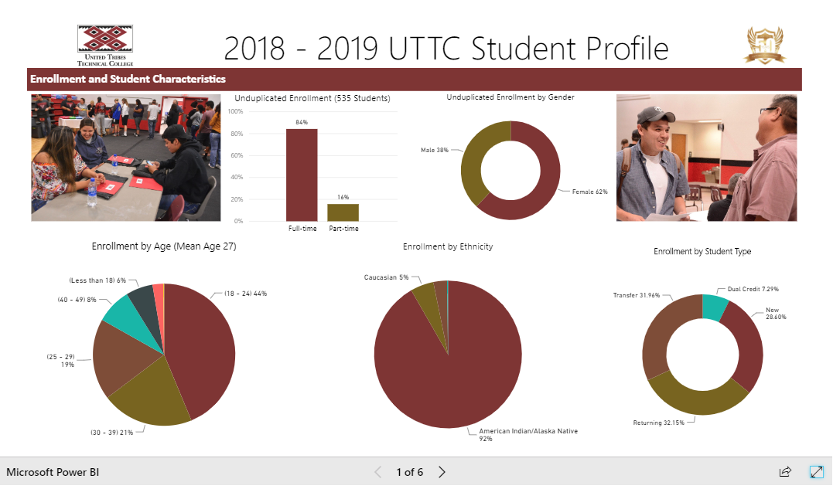
Preview of Student Profile Visualization on the website using Power BI

Co-Curriculum Assessment Plan to be implemented in 2019-2020 academic year.

Students helped to define “Student Success” at UTTC.
UTTC Definition of
Student Success:
Student success at UTTC extends beyond academic achievement to leadership development. Successful student leaders develop positive campus community relationships and display strong work habits, confidence, resilience, and belief in self.
Student success means different things to different people. UTTC needed to clearly define student success, so decided to start with students. Students were interviewed and asked what student success meant to them. Faculty and other academic personnel were then asked what they thought student success was. The data was analyzed to determine themes common to both groups.

“Leadership begins here” is the core theme in Co-Curriculum assessment.
The Co-Curriculum includes activities, programs, and learning experiences that complement, in some way, what students are learning through academics. There were four outcomes developed based on the definition of student success and grounded in the college’s motto: Leadership begins here. Leadership development will be measured in the co-curriculum. The four learning outcomes defined for the co-curriculum activities are:
- Student Leaders are prepared to learn, regularly attend class, complete assignments on time, and demonstrate other positive work habits that contribute to achieving career pathway goals.
- Student Leaders are confident and able to work through life challenges through effective planning and prioritizing.
- Student Leaders are open to new experiences and believe in their potential to acquire new skills and knowledge.
- Student Leaders perceive themselves as accepted members of and positive contributors to the campus community.
Student learning toward these outcomes will be measured across the campus in the college’s student Retention system, tutoring, Wellness Center activities, the library, athletics, and in student government.

Strategic Area #5: Infrastructure Improvement, Renovation and New Construction

Campus renovations require cross-campus cooperation.

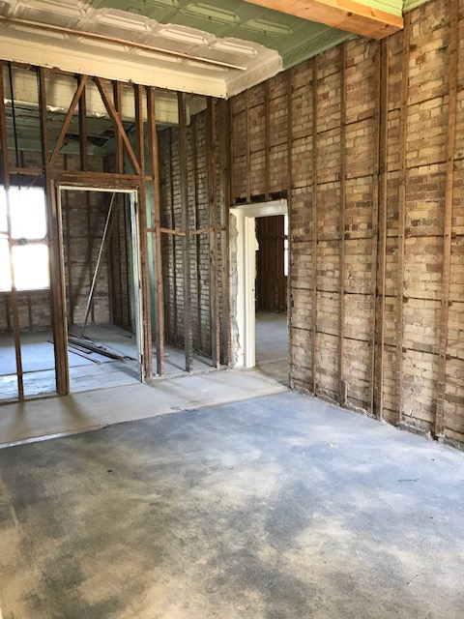
Education Building renovation begins.
The renovation of one of the campus’s largest buildings is underway. Originally a barracks for soldiers, the hundred-year-old Education Building has over 46,000 square feet of space that has been used for offices and classrooms. It housed General Studies, Teacher Education, and Human and Social Services programs as well as the library, disabilities services, Institutional Research, and other services.
A group from AmeriCorps helped with internal demolition during the summer of 2019. This helped put renovation ahead of schedule. The project is anticipated to take from 18 to 24 months to complete. Upon completion, the building will house the administrative offices for the VP of Academics, general studies and other designated faculty, classrooms, and an auditorium.

Renovations made to accommodate displaced programs.
Many of the faculty and degree programs that were formerly located in the Education Building were relocated to other areas of campus, including the Skills Center and the Science and Tech Building on the south campus. Three offices were converted from pre-existing lobby areas on the first floor and three on the second floor to accommodate the incoming instructors. The vacated nursing program offices and classroom spaces were available for some of the incoming faculty and programs. In the Skills Center, the computer lab was remodeled to provide better instructional space for the Computer Information Technology program. In addition, the Information Technology office area was renovated. The area is now more accessible and inviting for students and staff who need assistance from that area.

Campus improves security and safety through street and lighting upgrades.
Several other improvements were made across the campus. These include:
- A new playground was installed on the Theodore Jamerson Elementary school grounds on campus.
- A parking lot was put in at the Elementary school to provide off-street parking for teachers and parents.
- LED lighting was installed around All Nations Circle to light up the bowery and streets.
- LED lighting was installed at the elementary school basketball court and the gymnasium parking lot to provide greater security.
- LED lighting was installed at the college main entrance gate.
- A mobile solar unit was built and used to power lights at the UTTC International Pow Wow. The college is working to determine a place on campus where the mobile solar unit can be used to supplement power on a more permanent basis.

Strategic Area #6: Expanded Funding for Self-Sustainability

College Relations increases fundraising efforts at UTTC to grow Endowment.

Fundraising targets four primary areas
A new College Relations Director was hired in spring of 2019. Fundraising activities include garnering donations and sponsorships as well building the endowment fund for scholarships. Events Week includes the Tribal Leader’s Summit and International Pow Wow. Other events coincide with that week, including a softball tournament, fun run, and golf tournament. Cash donations, sponsorships, and “in kind” contributions totaled $263,400 for Events Week. The proceeds from the week are used for student scholarships.
A partnership was established with the Bismarck Tribune. A scholarship was endowed with the Tribune committing to $14,000 over the next three years. Other strategies are being developed to grow the endowment fund for scholarships. Board participation and support will be critical to these strategies and initiatives. The four primary funding campaigns include: a) Events Week Fundraising, b) Athletic Fundraising, c) Annual support for scholarships, and d) Capital Funding for building renovations.

Scholarships awarded approaches $700,000

UTTC Land Grant Office contributes to food security and campus energy independence.

Structures help to expand growing season.
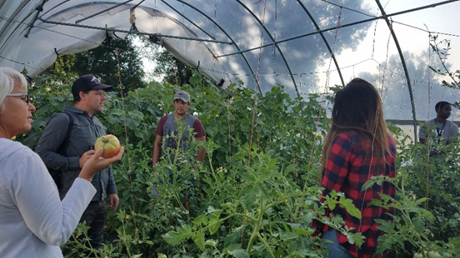
UTTC Land Grant Office received an additional $60,000 from an AIHEC partnership with the USDA-NRCS that is being utilized to build approximately 14,000 square feet of protected growing space. Here several different season extension strategies will be demonstrated and evaluated. This represents one of three research capacity building projects that the Land Grant Office has initiated. Tribal College Research Grant funds from the USDA (approximately $90,000 remaining from a previous research project) is being used to conduct research into soil remediation and crop diversity strategies in the college’s research garden plots.
The Land Grant Office is currently engaged in a partnership with several research institutions in developing a research proposal to investigate the effects of the office’s food sovereignty work on the health of the UTTC community.

Solar installation training offered at UTTC.
UTTC invested into an initiative to move the college campus towards energy self-sufficiency. UTTC hosted two solar installation training workshops, which led to the design and building of a mobile solar power unit. As a result, a partnership was developed that has generated a project to install a large solar array on the Skill Center. The goal and expectation is that this will lead to increasingly more solar installations on campus, and more students gaining valuable skills in renewable energy technology.

UTTC President Leander “Russ” McDonald, PhD (Dakota/Sahnish/Hidatsa), President’s Message; UTTC Strategic Plan 2015-2020
https://www.bls.gov/news.release/jolts.t16.htm
https://www.hhs.gov/ohrp/register-irbs-and-obtain-fwas/fwas/fwa-protection-of-human-subjecct/index.html#sectiona

