United Tribes Technical College
Academic Program Review

Graphic Design AAS Degree
Program Review 2018

Academic Program Review Schedule

An annual timeline for program review rotation will be published on the Office of Institutional Assessment (OIA) website page. Department Chairs, in collaboration with the OIA, are responsible for adhering to the review schedule for their units. Those units with specialized accreditation may incorporate many of those materials into this report but the UTTC Annual Program Review (APR) process and format as described here should be followed.

Instructions: Please complete all sections of this APR template. If your department offers more than one degree, diploma or certificate, one of these templates will be completed for each degree, diploma or certificate offered. There will be similarities between the reports, particularly as it relates to your department (1 department – multiple programs). If an item is not applicable, and there will be very few that are not, simply indicate “N/A”.

Department Chair name and contact information (phone, email):
Colleen Bredahl
Graphic Design
Department Chair/Instructor
Print Shop Manager
United Tribes Technical College
cbredahl@uttc.edu
701-255-3285 Ext. 1419
Part 1 – Program Review

- Program Demand:

 | UTTC Graphic Design AAS Enrollments
 | 2013 | 2014 | 2015 | 2016 | 2017
Fine Arts | 19 | 9 | 8 | 0 | 0
Media Arts | 0 | 0 | 0 | 0 | 0
Graphic Arts | 15 | 19 | 13 | 12 | 9
Total | 34 | 28 | 21 | 12 | 9

 | UTTC Graphic Design AAS Graduates
 | 2013 | 2014 | 2015 | 2016 | 2017
Fine Arts | 1 | 1 | 5 | 0 | 0
Media Arts | 2 | 0 | 0 | 0 | 0
Graphic Arts | 0 | 6 | 1 | 2 | 1
Total | 3 | 7 | 6 | 2 | 1
Include a brief summary below describing the status of your program meeting the following graduation rates for each academic year. Provide rationale for reasons your program is performing above or below the expected criteria.

The above table shows the five-year graduation total is 19, which is below the average of 30. In 2013 when the program was the Art/Art Marketing we went under a restructure with the loss of an instructor and a new one added, also we obtained the campus print shop Arrow Graphics. The program accepted these changes and we experienced a large enrollment in 2013. 2014 and 2015 stayed level without the Media Arts program, however, we did loose another instructor and now we were down to two instructors. Our graduation rate was acceptable in 2014-2015 with seven and six concurrent. In 2016 the current Fine Art instructor and Department Chair retired, once again the program went through another restructure, new degree plan, and the program name changed to Graphic Design. The program no longer offered a Fine Arts Degree and many students were advised to dropped out of the program by the then current department chair. This caused a spiral in enrollment.. However the few students the Graphic Design program had left graduated and stayed steady. The new students who enrolled in the Graphic Design program in 2017 are still active in the program and are doing well. I believe I will retain all these students. New Students will enroll in the fall of 2018 and the program will grow. The program has set a goal to graduate six students per year.

* Guidelines for graduation completion rates:
- Bachelor Programs: Average – 5 per year; 5-year total: 25
- Associate Programs: Average – 6 per year; 5-year total: 30
- Diploma Programs: Average – 5 per year; 5-year total: 25
- Certificate Programs Average – 8 per year; 5-year total: 40
(See APPENDIX A for types of programs excluded from review or from meeting the guidelines for completion.)

- Quality of Instruction and Curriculum

  - Program accreditation

    - For programs currently accredited include:
      - Name of accrediting body/organization
- Higher Learning Commission
      - Date most recently accredited
- 2011
      - Next reaccreditation date
- 2021
      - List recommendations from most recent visit and progress to date.
- As far as I know there were no recommendations specific to the Graphic Design Program

    - For programs seeking accreditation include:
      - Name of accrediting body/organization
- N/A – at this time, there are no programs in the AAS Graphic Design Degree seeking accreditation

      - Timeline for seeking accreditation
- N/A – at this time, there are no programs in the AAS Graphic Design Degree seeking accreditation

    - For all other programs include:
      - Date of most recent Academic Program Review (APR)
- N/A

      - List of recommendations from the most recent APR and progress to date.
- N/A
(Note: For first-time reviews, include N/A in response.)

  - Credentials of faculty

Colleen Bredahl
Female
White

Professional Development
  - Bachelors Degree in Business
  - Associates Degree in Graphic Design
  - CTE training and certification renewed 2017
  - Various CEU’s
  - Over 30 years in the industry
  - Associate Editor of “Against the Clock” Adobe Flash 2015
  - Certificate of Continuing Education in Photoshop - 2000
  - Adobe Flash CS4 Rich Content Creation - 2009
  - Adobe Flash ActionScript CS4 - 2009
  - Adobe Flash Advanced ActionScript CS4 - 2009
  - Adobe CS Software training – 2000
  - Jenzabar Advising Module Manger
  - Assistant Editor of Adobe Against the Clock/Flash 5.
  - Multiple Adobe CS Video trainings

  - No Grants awarded for the last 5 years
  - No Grants submitted for the last 5 years

- The Art/Art Marketing program was included in the title three grant, though not directly awarded to the program we were written in as part of the electronic education piece. The Graphics program responsibility was to create games, which would be, used in educating the students through gaming. We created mini games, which were used as practice tests for students. The program also wrote a script and developed a 3D game, which allowed future students to tour the campus through the game, and provide information about UTTC and different areas and programs of the campus.

  - Curriculum
- Describe the strengths of the curriculum, its quality and rigor, and justification for your response.
- The Graphic Design department is committed to encouraging and helping students to develop skills necessary for employment or self-employment in the Graphic Design industry.
- The coursework reflects UTTC’s commitment to preserving the traditional arts of native people while including state-of-the-art technology with a fully functional print shop. Students receive real work experience by working on projects for departments on campus.
- Students are introduced to a variety of traditional and contemporary designs with a heavy emphasis on developing their own individual style and emphasis on developing products.
- Throughout the coursework, professional presentation and marketing strategies are explored and emphasized. The goal of the department is to give our graduates a competitive edge when seeking employment or presenting themselves and their work to prospective clients and employers. A wide variety of opportunities await qualified graduates as entry-level employment or as a freelance designer.
- The assignments for the courses are instructor lead with an on the job training experience. Students follow the instructor demonstrations as they learn different software and tools. Once this instructor lead example is complete students create their own projects using the techniques demonstrated by the instructor. They also are given a written quiz to make sure students understand the verbiage of the software and the industry.
- As the students continue in their education the courses become more project based. Students will be given a project either individual or group and need to complete the project with the knowledge they learned in previous courses. The courses build on each other to show growth in design, production and software usage.

- Students get the opportunity to participate in a Job Shadow program. Businesses in the community participate in the Job Shadow event and give the students the opportunity to work for these business opportunities in the industry. The internship class allows the students to either intern with a local company or they will work in the programs print shop.

- Identify the emerging trends in your field and how your program and faculty are poised to address the trends.

The Graphic Design field changes consistently. My program evolves with many different aspects of design, whether it is in visual, media, web, textiles, marketing or other aspects. Graphic Design program sticks to the core of production and design. Students are only here 2 years and I have to keep focused in several areas, I feel this better prepares my students to be able too expand in to any creative design field.

However the trending areas focus on these basic new design styles in 2017 keeping up on trends give the students an understanding of the popular designs:

The “Glitch” Effect
The glitch effect has been one of the most popular trends in the digital world lately. What was once annoying has now been turned into a truly wanted effect.

The “Ruined” Effect
Graphic designers have been obsessed with the “art of destroying”. Everything that includes splashing, scratching, ripping off, breaking or any other form of ruining the aesthetics of a composition is considered modern good design in 2018.

“Color Channels” Effects
Color channel technique allows designers to create great illusional effects. A holograph, a hallucination, a distorted reality… all of these are highly influential on the viewer
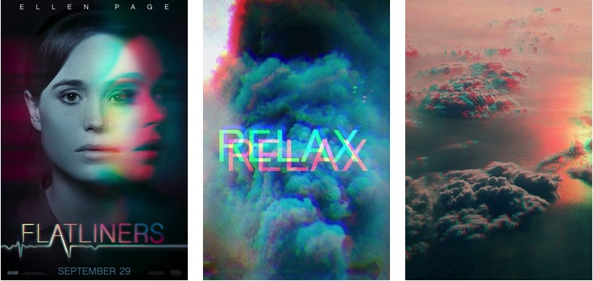

The year of Double.
Double exposure has been a thing for several years now, and this technique amazes the viewer.
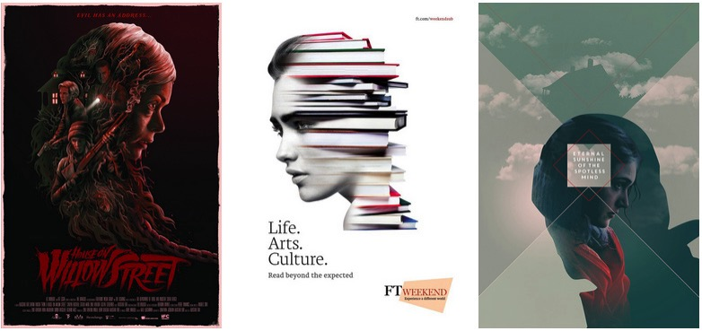

Double Exposure Duotone
This trend is a hybrid from Double Exposure and Duotone, plus using color channels. In short, doubling the image or using two different overlapping images in monochrome colors achieves double exposure duotone.

Double Light
This effect transforms simple compositions into new edgy, modern looking ones. Double light is an effect that can be achieved with two actual sources of light, or color channel splitting.

Wave Classic Duotone Goodbye…
Duotone translated into Double exposure duotone will be a major trend next year.

Creative typography
Creative typography can be combined with other techniques or used solely in the design.
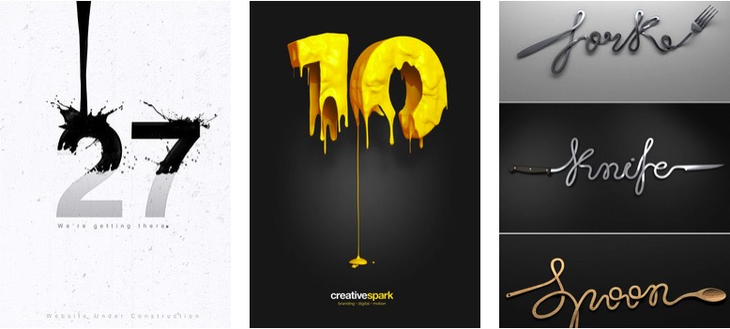

Cropped Typography
The art of erasing parts of the letters while still keeping their readability requires a lot of creativity and professionalism.
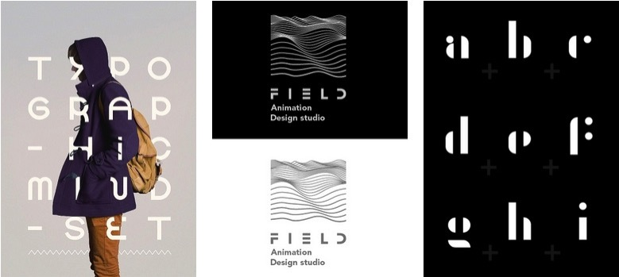

Chaotic Typography
Chaos translates into a chaotic typography. In other words, say “No” to aligning and “Yes” to the unconventional order of letters and words.
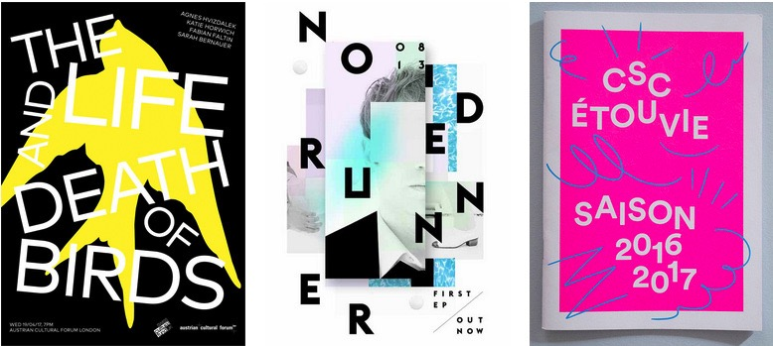

Typography as Real Life Elements
Typography tightly interacts with other elements of the composition. The achieved effect is: letters turned into real-life objects.

Negative Space Designs
We named negative space a positive trend not because negative and positive attract each other in physics, but because in graphic aesthetics negative space techniques evoke quite positive emotions.
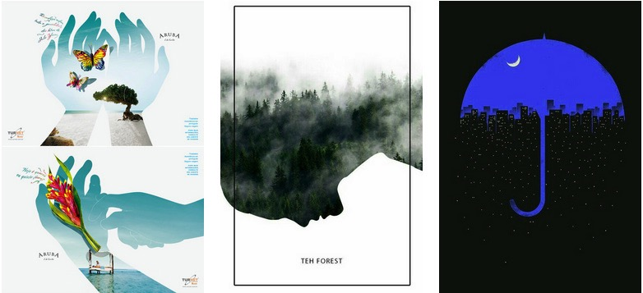

Negative Space Typography
Mixture of Negative space and Typography. Elements from the back come to the front through the wording

Colorful 3D Substance
Bright colors plus a 3D composition is what client want.
Bright colors can certainly make a design pop
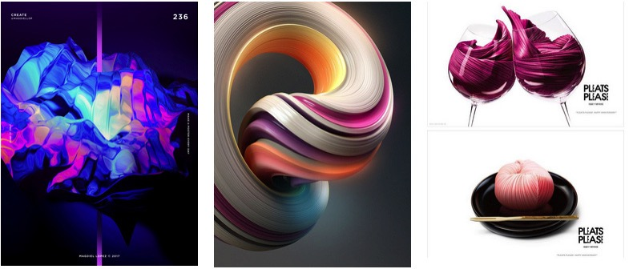

One Color 3D Design
Product presentations using the same background color as the product presented. The product “pops” thanks to the volume created by the 3D techniques.

Metallic Elements
Addition to bright colors, metallic elements enter the world of graphic design to create the “Wow” effect. Often combined with other hot trends such as 3D compositions and creative typography.

Color Transitions / Gradients
Colorful gradient, combined with grayscale images combines the old with the new.

Artistic Illustrations
When it comes to graphic design, illustrations always bring a special unique vibe to the piece. Illustrations are presented in combination with other graphic designs such as negative space, 3d structures, the “double” and more.
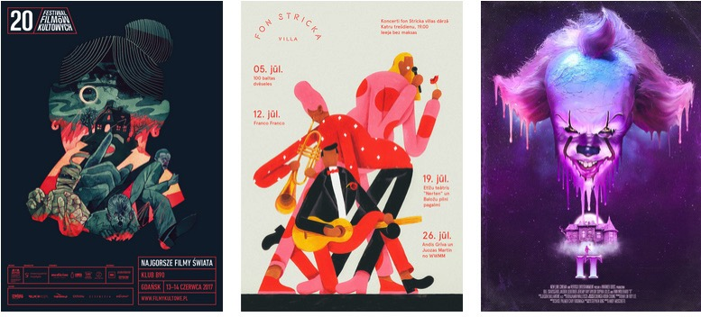

Illustrations Over Photos
Combining photos with digital drawing. This technique boosts the effect of the photo and brings the composition a new edgy look.

Papercut Illustrations
Papercut illustrations recreate compositions made of different layers of paper, which means depth, and specific textures are must-have elements.

Quick Facts: Graphic Designers
2016 Median Pay | $47,640 per year  $22.90 per hour
Typical Entry-Level Education | Bachelor's/AAS degree
Number of Jobs, 2016 | 266,300
Job Outlook, 2016-26 | 4% increase
Employment Change, 2016-26 | 11,100

Occupational Employment and Wages, May 2016

Information retrieved from the Bureau of Labor Statistic

Graphic Designers
Design or create graphics to meet specific commercial or promotional needs, such as packaging, displays, or logos. May use a variety of mediums to achieve artistic or decorative effects.
National estimates for this occupation:
Employment estimate and mean wage estimates for this occupation:
Employment (1) | Employment  RSE (3) | Mean hourly  wage | Mean annual  wage (2) | Wage RSE (3)
210,710 | 0.9 % | $25.14 | $52,290 | 0.4 %
Percentile wage estimates for this occupation:
Percentile | 10% | 25% | 50%  (Median) | 75% | 90%
Hourly Wage | $13.44 | $17.10 | $22.90 | $30.45 | $39.43
Annual Wage (2) | $27,950 | $35,560 | $47,640 | $63,340 | $82,020

Industry profile for this occupation:
Industries with the highest published employment and wages for this occupation are provided.
Industries with the highest levels of employment in this occupation:
Industry | Employment (1) |  | Percent of industry employment |  | Hourly mean wage |  | Annual mean wage (2)
Specialized Design Services | 29,040 |  | 21.16 |  | $26.26 |  | $54,620
Advertising, Public Relations, and Related Services | 22,290 |  | 4.60 |  | $25.92 |  | $53,900
Printing and Related Support Activities | 18,680 |  | 4.14 |  | $19.96 |  | $41,520
Newspaper, Periodical, Book, and Directory Publishers | 16,610 |  | 4.39 |  | $22.36 |  | $46,510
Computer Systems Design and Related Services | 9,610 |  | 0.49 |  | $28.03 |  | $58,300
Other Miscellaneous Manufacturing |  | 8,280 |  | 2.92 |  | $20.32 |  | $42,270

Top paying industries for this occupation:
Industry | Employment (1) | Percent of industry employment | Hourly mean wage | Annual mean wage (2)
Federal Executive Branch (OES Designation) | 1,570 | 0.08 | $38.05 | $79,140
Aerospace Product and Parts Manufacturing | 310 | 0.06 | $36.54 | $76,000
Semiconductor and Other Electronic Component Manufacturing | 270 | 0.07 | $34.27 | $71,280
Legal Services | 270 | 0.02 | $32.11 | $66,790
Wireless Telecommunications Carriers (except Satellite) | 40 | 0.03 | $31.32 | $65,140
These estimates are calculated with data collected from employers in all industry sectors, all metropolitan and nonmetropolitan areas, and all states and the District of Columbia. The top employment and wage figures are provided above.
The percentile wage estimate is the value of a wage below which a certain percent of workers fall. The median wage is the 50th percentile wage estimate--50 percent of workers earn less than the median and 50 percent of workers earn more than the median.
More about percentile wages.
(1) Estimates for detailed occupations do not sum to the totals because the totals include occupations not shown separately. Estimates do not include self-employed workers.
(2) Annual wages have been calculated by multiplying the hourly mean wage by a "year-round, full-time" hours figure of 2,080 hours; for those occupations where there is not an hourly wage published, the annual wage has been directly calculated from the reported survey data.
(3) The relative standard error (RSE) is a measure of the reliability of a survey statistic. The smaller the relative standard error, the more precise the estimate.
(8) Estimate not released.
(9) The location quotient is the ratio of the area concentration of occupational employment to the national average concentration. A location quotient greater than one indicates the occupation has a higher share of employment than average, and a location quotient less than one indicates the occupation is less prevalent in the area than average.

- Explain the role and function of online and hybrid learning in your programs.
There are no online graphics courses.

- Articulate the status of the program core curriculum and if it has been updated and approved by the UTTC Curriculum Committee within the past 3 years. If it has, provide an overview of updates completed. If it hasn’t, what particular areas have you identified as needing to be updated?
The Graphic Design program was completely redesigned in 2016. With the loss of the Fine Arts program and the Media Arts Program the classes from these programs were depleted. The new program was established as the Graphic Design program. The degree plan and course descriptions were updated and approved by the UTTC Curriculum Committee. The program consists of one instructor who also is the department chair. No new courses were developed just redesigned with new description and assignments. Instructor currently teaches 7 students in all the courses. The program student classroom can hold 10 freshmen in my one classroom. In return I can also hold 10 sophomores. The Instructor is fully versed in the graphic design industry, she has over 30 years of experience and holds a bachelors degree in business and AAS in graphic design. The program consists of an Internship that allows students to receive real world experience, if there is no community internships, then the students will work at the graphic design production facility. The students also participate in the job shadow experience.

Supporting Data

Common data elements (required): | Common data elements (for future APR):
- Faculty teaching load  - Faculty characteristics  - Faculty service  - Number and percentage of diverse faculty | - Faculty by full-time/part-time status  - Number of faculty with terminal degrees  - Online and hybrid programs and courses offered  - Number of Community Based Learning (CBL), Capstone, or other community-based courses offered

  - Program reputation
    - Include a brief description of any indicators of program reputation such as demand (e.g. waiting lists or over enrollment) for admission into program, employer data/feedback, etc.
There is no waiting list for enrollment into the Graphic Design program. We are at the infancy of our new degree program and anticipate an increase in enrollment in the future. I currently have been in contact with a couple of students from Canada that are interested in the program. My graduates in the past have either went on to higher education in a bachelors program or are working in the field or are working as a freelance designer. Examples: One student went on for their bachelors degree at SDSU, one worked as a designer in the courts system in SD, one went to New York and worked for a gaming company and worked as a fabric designer. Another went to work at a print shop, also for the historical society. A student teamed up with their parents to develop a magazine for Native American entrepreneurs. Two went on to get their bachelors in the business program. One went on to get a second AAS degree in the CIT program. Another student went on to get his bachelors degree from California. Another created his own t-shirt design company. One of my graduates does freelance comp illustrations for characters in gaming. He also illustrated and designed a children’s book. I do not know where every single graduate went or what he or she is doing. These are students that keep in touch with me so I can help them and give them some advise now and then.

  - Curriculum of major or specialization
    - Include a list of core courses by prefix, number, and title (do not include general education course unless required as part of the core requirements.)

ART 142 Design/Desktop Publishing
ART 225 Illustration
ART 230 Graphic Design Industry
ART 239 Graphic Design Production
ART 242 Adv. Design/Desktop Publishing
ART 270 Portfolio Presentation
ART 297 Graphic Arts Internship
BAD 201 Principles of Marketing
CSC 103 Introduction to Computer Graphics
HUM 113 Drawing I
NAS 112 Tribal Arts I
NAS 212 Tribal Arts II
LAB 104 Graphic Design Lab

  - Distance delivery of program
    - Note if the program is offered online and a brief overview of the online degree status, enrollment trends, and plans for the program.
Graphic Design is not offered online

  - Quality of Assessment Plan/Data
    - Include a brief description of the program assessment plan and how the data are used to inform decisions related to program quality and student learning.
The Program plan for assessment in the Graphic Design program assesses the quality of learning from two broad perspectives. Each perspective allows for a unique set of questions to be asked about student learning. The first perspective asks questions about the quality of student learning within the Graphic Design program. The second asks question about the quality of learning within courses, focusing on the quality of performance objectives, classroom assessment practices and day-to-day instruction.
Graphic Design instructor drafts program objectives, develop assessment strategies, collect and review data, and make recommendations based on the data. The plan is designed to improve the learning experiences of Graphic Design students.

The perspective will be guided by following program learning outcomes:
- Present and Market an E-Portfolio
- Implement Safety Procedures
- Utilize Technology
- Illustrate Creative Design

Outcome 1: Present and Market an E-Portfolio will be measured in ART270 Portfolio Presentation.
This course will be measured using the following tools; teacher evaluation, project checklist, flowchart, rubric, and final e-portfolio and presentation using a 1 thru 5 rating with interview questions during a peer review.
Outcome 2: Implement Safety Procedures will be measured in ART239 Graphic Design Production.
This course will be measured using the following tools; check list with vocabulary of industry, demonstration and identification of tools, and test with tool usage. The assessment is to improve the safety procedures and the proper use of equipment in this class.
Outcome 3: Utilize Technology will be measured in ART230 Graphic Design Industry.
This course will be measured using the following tools; equipment, industry software, and computers, to allow the students to receive real world experience through large projects and guidance from the advisory board.

Outcome 4: Illustrate Creative Design will be measured in ART225 Illustration.
This course will be measured using the following tools; composition of a children’s story, illustrating the children’s story and using the technology and printing equipment to create a fully produced book. Students’ will also use tools and technology to create instructional illustration, caricatures, and muscle and bone structure.

  - Department Action Plan
    - Include a brief description of any plans for the program that appears in the department action plan (i.e., facilities upgrades, curriculum changes, online delivery, enrichment learning opportunities, etc.), as well as an overview of the summary of progress reported on the action plan.

The following three main department goals are developed in the department action plan.
- Recruit, retain, and graduate competent professionals who meet industry requirements.
To recruit, retain, and graduate competent professionals who meet industry requirements, courses are developed to give the student relevant information and prepare them for the advancement to the industry. This is accomplished through the continued assessment and evaluation of courses currently offered and the instructor maintaining communication with advisory board about the industry.
- Design and create printable and electronic documents as used in the industry.
To Design and create printable and electronic documents as used in the industry, instructor will guide students with the rules and equipment used in the industry. They will get real world experience through many different projects available in the production shop.
- Create a professional quality E-portfolio and marketing packet.
To create a professional quality E-portfolio and marketing packet, students will gather all the projects they have created since their freshman year in every class and will create the e-portfolio based off of the job they will research. This job description will guide the student through what the potential employer is looking for in an employee. The instructor will give guidance to the students and help develop a cover letter and resume. When the e-portfolio is complete then the student will use all the same information and create his or her own marketing packet to give to the potential employer.

  - Other: The Graphic Design program is set up to give all the students an opportunity to get real work experience through our production shop. Programs on campus bring their design and printing needs to our program. This allows the students the opportunity to create and develop real projects. No other school has this opportunity for the students. With the creation of the e-portfolio students can show proof of real work experience to the potential employers.

- Mission Centrality

  - Describe how the program supports the mission and strategic goals of UTTC.

The mission statement is as follows:
“United Tribes Technical College provides quality post-secondary education and training to enhance knowledge, diversity, and leadership for all indigenous nations.”

The Strategic Plan is as follows:
    - Commitment to Student Learning
    - Student Success and Completion
    - Recruitment and Retention of Students and Employees
    - Institution Research Culture and Effectiveness
    - Infrastructure Improvements
    - Renovation and new Construction
    - Expanded Funding for Self Sustainability

The Graphic Design department ensures that this mission is supported and also UTTC’s Strategic Plan. The instructor continues to do research in the industry to stay on top of the latest technology and advancements in the industry. This information is then introduces and confirmed in the classes so the students can achieve their goal of graduation.
The Graphic program is committed to giving the students the best education through updated course and instruction. The courses are set up to build on each other to grow with information for the student’s advancement.
The instructor keeps in touch with the students so the instructor can keep the students on track with their education. The instructor keep in contact with the recruitment department at UTTC to stay informed about what the recruitment department needs to be able to support the increase in the programs enrollment. The instructor also works side by side with the students others instructors to help them stay on track.
The Graphic Design degree plan is structured to give the student not only industry courses but also cultural courses with the addition of the Tribal Arts courses.
The graphic’s program researches technology to offer the students the most up-to-date technology the industry has to offer. The students learn on equipment, which will allow them to be familiar with the equipment used in the industry. The program keeps the computers updated and the software updated. The production equipment stays the same, however, the plan is to save money and to update one piece of equipment every two years. The Graphic design program has been fortunate in the fact we were able to be a part of a grant with the Tribal Arts courses and get a total renovation in our area. The renovation allows the students more room and a very beautiful environment for which to learn. The programs’ production area receives money from the other departments on campus for doing projects for their departments. The instructor is setting this money aside for the students benefits and use for the next new piece of equipment in the production area.

  - Describe how the program contributes to other programs across campus (i.e., general education courses, interdisciplinary program, etc.)
The graphic design program teaches skills that are necessary for many programs on campus. Programs and departments on campus need design skills to create posters, business cards, letterheads and many other marketing needs. The courses work well with the business program courses to give students an edge in the marketing industry.

  - Include placement data for graduates and indicate if graduates are working in the field or not.
 | UTTC Graphic Design AAS Graduate Job Placements – In Field
 | 2013 | 2014 | 2015 | 2016 | 2017
On Campus Graduates | 1 | 3 | 1 | 2 | 0

  - Other: Data is based off of the information given to me at the time the students let me know what their job situation was at the time. I am not sure all these students are still working in the field.

- Program Productivity

  - Ratio of student credit hours per full-time faculty (FTE)
The academic ratio of student credit hours per faculty is 30 to 1 per academic year. Each Instructor needs to teach 15 credit hours a semester with a total of 30 per year.

  - Ratio of student enrollment in core program courses per full-time faculty (FTE)
The enrollment ratio of student per faculty is 20 to 1 per academic year. The classroom has 10 computers and can hold 10 freshmen and 10 sophomores.

  - Ratio of student enrollment in courses outside of the program (Gen. Ed.) per full-time faculty (FTE)
The ration of graphic design students in general education is 10 graphic students to 1 instructor. Gen ed classes vary in size, however, when graphic design is at full capacity. 10 of my students will all be in the same general ed courses. Freshmen need to take gen ed in the mornings and sophomores in the gen ed in the afternoon.

  - Course enrollment
Number of classes exceeding UTTC minimum (7 for 100-200 level, 5 for 300-400 level), as well as number of classes underperforming in enrollment.

Fall and spring 2017-2018 Graphic Design AAS program enrollment numbers per core courses.
Course | Student Enrollment number
ART 142 Design/Desktop Publishing | 9
ART 225 Illustration | 0*
ART 230 Graphic Design Industry | 0*
ART 239 Graphic Design Production | 1*
ART 242 Adv. Design/Desktop Publishing | 5*
ART 270 Portfolio Presentation | 0*
ART 297 Graphic Arts Internship | 0*
LAB 104 Graphic Design Lab | 7
CSC 103 Introduction to Computer Graphics | 5*
*= Classes not exceeding UTTC minimum of seven for AAS 100-200 level courses.

  - Other: Graphic Design program is in a rebuilding year and will be increasing enrollment in the fall 2018-2019 semesters. I have no sophomores this year so all the numbers will be sophomores next year and the increase will happen with the incoming freshmen.

- Student Advising

- Describe your department philosophy for advising students. Who serves as the primary advisor and how do you view the role of the advisor? Include discussion about your position on proactive advising (formerly referred to as intrusive advising) and if it is implemented in your department.
The graphic design program has only one instructor/department chair and she serves as the main advisor, the director of CTE has also been assigned as an advisor in the event the department chair is not available to advise students. Students are advised by trying to keep all the freshmen together in classes to make sure they get to know each other. Also the general education courses need to be based on the students’ ability to be successful in their courses. The focus is to have a friendly based advising policy. The instructor reviews the degree plan with the students and discusses what courses need to be taken in order so the student is successful. I also discuss with the students what general education course they would like to take. I want to make sure the student is able to voice their opinion about what course they will take in their degree plan and sculpt their degree.

- Explain your department’s approach to advising, including the inclusion of practices used to advise students on general education requirements and degree completion pathways.
Listed is the basic plan for fall freshman as they move to their graduation date. This works well and gives the students some options in their general education classes. This also supports the incoming spring freshmen so the new students will get to know the fall freshmen. The only area, which causes a little problem, is the prep courses Small adjustments are made to get students in prep courses caught up to the other students, such as taking summer school.

Graphic Design Suggested Fall incoming Classes – Total Credits 60 credits
Suggested Classes for Fall Freshman
General Education (These are suggestions anything on the degree plan will work)
COM 110 Fundamentals Public Speaking 3 credits
FND 106 First Year Experience and Healthy Liv. 2 credits
CSC 103 Introduction to Computer Graphics 3 credits
MTH 101 Introduction to Algebra 3 credits
_______
Total 11 credits
Core
ART 142 Design & Desktop Publishing 3 credits
LAB 104 Graphic Design Lab 1 credit
________
Total 4 credits
Fall Freshman Total Credits 15 credits

Suggested classes for Spring Freshman
General Education (These are suggestions anything on the degree plan will work)
NAS 112 Tribal Arts I 3 credits
PSY 111 Introduction to Psychology 3 credits
ENG 110 Composition 3 credits
HUM 113 Drawing I 3 credits
_______
Total 12 credits
Core
ART 242 Adv. Design & Desktop Publishing 3 credits
LAB 104 Graphic Design Lab 1 credit
________
Total 4 credits
Spring Freshman total credits 16 credits
Freshman total credits 31 Credits

Suggested Classes for Fall Sophomores
General Education (These are suggestions anything on the degree plan will work)
BAD 201 Marketing 3 credits
NAS 212 Tribal Arts II 2 credits
_______
Total 5 credits
Core
ART 239 Graphic Design Production 4 credits
ART 225 Illustration 4 credit
LAB 104 Graphic Design Lab 1 credit
_______
Total 9 credits
Fall Sophomore total credits 14 credits

Suggested classes for Spring Sophomores
General Education (These are suggestions anything on the degree plan will work)
ART 270 Portfolio Presentation 3 credits
HIS 104 US History since 1877 3 credits
_______
Total 6 credits
Core
ART 230 Graphic Design Industry 4 credits
ART 213 Graphic Arts Internship 4 credits
LAB 104 Graphic Design Lab 1 credit
________
Total 9 credits
Spring Freshman total credits 15 credits
Sophomore total credits 29 Credits
- Have you ever advised a student to pursue a different field of study at UTTC or another institution? If so, what were the circumstances?
I have not advised a student to pursue a different program or school. The only time I advise students to go into a different program is after they graduate and I will advise them what program would be best for their life and combination with the graphic program.

- Describe how you evaluate the effectiveness of your advising practices, including the impact of your advising techniques on retention and degree completion.
Graphic design advising practices are based off of the program success with the students whether it is verbal or written. Students fill out course evaluation for all courses and upon graduation they fill out an exit survey. This information is given to the department chair and this information is used to adjust the program if needed. Also when students stick with the program and freshmen graduate this is very successful for the program. These students also spread the good news about the program and recruiting by word of mouth is very important.

- Persistence and Completion

- Identify and describe any barriers to student persistence and degree completion in your program/department (for example bottleneck courses or courses with significant D, W, F rates), and what efforts are being undertaken by the department to alleviate those barriers.
The Graphic Design program does not have any bottleneck of courses or a significant D, W, or F rates, with the current degree plan.

- Specifically address how students are being supported and how that will lead to improved rates of persistence and degree completion. Are there any supports that specifically address the needs of students from diverse backgrounds? Please describe.
United Tribes Technical College offers many different kinds of funding opportunities for students. The better the students’ grades are and their attendance the better chance for the scholarship opportunity. So letting the students know these opportunities are available and if they work hard they will get rewarded, creates drive and perseverance in the students. Graphic Design advisor keeps a close eye on the students’ ability to be successful and suggests different ideas to help keep the student on track. The students have tutors available if they are struggling in any course. The graphic design program has the ability to offer scholarships if needed to help students on their successful track. Individual needs are assessed and provided by the Wellness Center and the Office Disability Support Services located on the UTTC Campus.

Supporting Data

Common data elements (required): | Common data elements (for future APR):
- Classes with high DFW rates  - Course sequence  - Degree plan  - Time to Completion  - Retention and persistence rate | - Enrollment demographic data  - Number of degrees awarded, include diplomas and certificates  - Number/proportion of diverse students  - Gainful employment information (certificates)

- Assessment of Student Achievement

- Evidence of Student Learning

- List and number the expected student learning outcomes for your program. Outcomes should explicitly describe what students know, understand, or are able to do. Include the performance indicators for each program learning outcome. Identify the UTTC institutional learner outcome(s) (ILO) that have been assessed in the program courses – which ILOs, in which courses, and how was it assessed.

Graduates of Graphic Design Associates of Applied Science degree will:
1. Present and Market an E-Portfolio
a. Create a flowchart for organization and flow
b. Develop a personal marketing packet
c. Display products in a professional manor
d. Write a clear and concise cover letter and resume

This outcome is introduced in the following courses: NAS 112 Tribal Arts I, HUM 113 Drawing, CSC 103 Introduction to Computer Graphics, ART 142 Design/Desktop Publishing, and ART 225 Illustration. These courses introduce the students to the beginning of the graphic design process. Students start out with many different projects as they learn software and all about the industry. The projects the students complete are saved and used in their final portfolio.

This outcome is reinforced in the following courses: ART 230 Graphic Design Industry, ART 242 Advanced Design/Desktop Publishing, and ART 239 Graphic Design Production. These are upper level courses that reinforce the beginning courses and teach the students about the advanced methods of the graphic design industry.

This outcome becomes proficient in the following courses: ART 297 Graphic Arts Internship, NAS 212 Tribal Arts II and ART 270 Portfolio Presentation. These are the final courses to complete the outcome. Students received these courses in their final semester and create the E-portfolio, which they will use to apply for jobs and interview with a potential employer.

2. Implement Safety Procedures
a. Demonstrate how to use equipment safely
b. Understand procedures to follow in case of an accident
c. Identify where all safety materials are located

This outcome is introduced in the following courses: NAS 112 Tribal Arts I, CSC 103 Introduction to Computer Graphics. Students learn how to use the tools of the industry and the safety precautions they need to know in the industry.

This outcome is reinforced in the following courses: NAS 212 Tribal Arts II, and ART 230 Graphic Design Industry. These are advanced course, which reinforce the safety procedures in the industry. The students are given more advanced instructions on the tools of the industry.

This outcome is proficient in these courses: ART 230 Graphic Design Industry, ART 239 Graphic Design Production and ART 270 Portfolio Presentation. These are advanced courses and the students become very proficient with the tools and safety procedures used in the industry.

3. Utilize Technology
a. Implement production equipment
b. Recognize the correct use of proper technology
c. Utilize Macintosh computers

This outcome is introduced in the following courses: NAS 112 Tribal Arts I, HUM 113 Drawing, CSC 103 Introduction to Computer Graphics, and ART 142 Design/Desktop Publishing. These courses introduce students to new software and beginning technologies in the industries. This is the first introduction to technology in the industry.

This outcome is reinforced in the following courses: ART 225 Illustration, ART 230 Graphic Design Industry, ART 242 Advance Design/Desktop Publishing. These courses increase the technology information in the industry. Students receive the second part of teachings for all the software and equipment.

This outcome is proficient in the following courses: NAS 212 Tribal Arts II, ART 230 Graphic design Industry, ART 239 Graphic Design Production, and ART 270 Portfolio Presentation. These courses are the advanced stages for technology. The student can operate the equipment and software proficiently and with little or no assistance.

4. Illustrate Creative Design
a. Collaborate with clients about project design
b. Proper use of design
c. Utilize design to develop composition

This outcome is introduced in the following courses: NAS 112 Tribal Arts I, CSC 103 Introduction to computer graphics, and ART 142 Design/Desktop Publishing. Students learn to use the illustration aspects of the software and learn how to draw in the classes.

This outcome is reinforced by the following courses: ART 242 Advanced Design/Desktop Publishing, HUM 113 Drawing. These courses increase the students drawing and illustration skills. These prepare students for the final creative of illustration design.

This outcome is proficient in the following courses: ART 225 Illustration, NAS 212 Tribal Arts II, ART 270 Portfolio Presentation. These courses are the final course used for students to create a children’s book. Students write and illustrate a book based on Native American culture.

Graduates of United Tribes Technical College will:
- Exhibit effective oral and written communication. (Communication)
  - Organize various types of communication
  - Articulate content knowledge
  - Demonstrate appropriate delivery (i.e. body language, tone, voice)
  - Apply mechanics of writing (standard grammar, punctuation, spelling)

- Analyze information from diverse sources. (Critical Thinking)
  - Identify issues
  - Evaluate sources
  - Apply solutions
- Develop solutions to mathematical and scientific problems (Quantitative & Scientific Reasoning)
  - Interpret data from a variety of sources
  - Demonstrate hypothesis-based problem solving
  - Estimate answers for reasonableness
  - Communicate quantitative information
- Demonstrate skills necessary for living and working in a global society. (Personal & Social Responsibility)
  - Demonstrate collaboration skills
  - Identify ethical norms for conduct
  - Exhibit knowledge of diverse cultures, identities and societies
  - Model professional behavior (e.g. attire, timeliness, reliability, initiative)
• Exhibit effective oral and written communication. (Communication)
Institutional
Engage in effective interpersonal, oral, and written communication appropriate for the audience, situation and (inter) cultural context. Communication and expression may be written or oral, verbal or nonverbal, informational or artistic.

Graphic Design
The graphic design department fulfills this outcome by assigning students a project to write a children’s book. Students must write many drafts before the final is finished. Graphic Design follows the writing process rules, prewriting, drafting, revising, editing/proofreading and publishing.

• Analyze information from diverse sources. (Critical Thinking)
Institutional
Effectively locate, analyze, evaluate, synthesize, and apply information from diverse sources.

Graphic Design
The graphic design program fulfills this outcome by doing research on finding a job that matches the students skill and degree level. Students must analyze the job descriptions and match them up with their skills. They need to research the company and read every part of the job description and gather all their appropriate skills that apply to the potential job. Students will determine if this position will suite their financial needs and responsibility.

• Develop solutions to mathematical and scientific problems (Quantitative & Scientific Reasoning)
Institutional
Use processes, procedures, data, or evidence to solve problems, and make effective decisions for academic or professional needs.

Graphic Design
The graphic design program fulfills this outcome with the production class. Students need to calculate the print layouts so they know how many objects can be put on the page and then calculate the number of print runs. The students will also calculate the bills to create invoices to bill the clients. They keep a schedule so the projects get completed on time and at the client’s necessary date and time.

• Demonstrate skills necessary for living and working in a global society. (Personal & Social Responsibility)
Institutional
Demonstrate awareness of personal responsibility in one’s civic, social, and academic life; indigenous cultural values or practices; and an understanding of the diverse traditions of the world.

Graphic Design
The graphic design program develops an understanding of traditions and values through the design they create. Students need to discuss the wants and needs of the clients to better understand how to design what clients need for their projects. This information is then portrayed by the designs the students create for the clients. Students are taught the design needs of the client and not what the student wants to design. The student achieves this by asking the client questions about the project or event. Students are taught in class how to interpret the clients’ personality and needs so they can better serve the clients deign requests.

- Describe the kinds of experiences you expect students to have inside and outside of the classroom to meet these learning outcomes.
The graphic design program allows the students to have first hand experience in the printing industry with the availability of the production room. Students work with clients about there projects and discuss what the clients needs are for their projects. Students learn the software and how to create many different projects, which can be used on clients’ projects. Every experience they receive in the classroom and the production room allows the student to grow as a designer and can take these experiences into the work world.

- Evaluation of Student Academic Performance

- Present justification that students graduating from your program are meeting the expected level of proficiency for the Institutional Learner Outcomes. Are they all being met? If so, explain. If not, what is your plan to increase your students’ knowledge and skills so they meet the expected criteria for the ILOs?
The Graphic Design program justifies the criteria for the ILO’s through the ART270 portfolio presentation class. This class requires the student to gather all the projects the student has created since he/she started as a freshman. The student also must do research in finding a job they will qualify for and we discuss this information in class. The students understand how to read a job description and compare what the employer is looking for and what talents the student has to offer. The students then creates a resume and cover letter to match what the employer is looking for in an employee. Students design and create an e-portfolio and a marketing packet to present to the potential employer.

- Specify which direct measures you are using to assess student learning. Direct assessment includes students’ demonstration of knowledge, skills and abilities.
The instructor demonstrates how to use the software tools and create many projects in the Graphic Design courses. Once the demonstration is complete the student must create their own design using the demonstrated techniques. They also have to complete a quiz based off of the demonstration information. These techniques prepare the students for advances in the graphic industry. Each class builds on each other to provide the student with the best opportunity for advancement.

- Analysis of the Results of Assessing Student Academic Performance

- Report and discuss the findings from each learning outcome assessment activity.
The first ILO that will be assessed is “Exhibit effective oral and written communication, (Communication)”. The students will take a class (ART 225 Illustration) in their sophomore year that will require them to write a children’s book. The story will go though the complete writing process of prewriting, drafting, revising, editing/proofreading and publishing. Students will also illustrate the book to match their story. The data will be collected using the UTTC writing form.

- Review Assessment Plan to see if any changes or modifications will create a more meaningful process.
A future plan to increase the writing and communication capabilities of the student will be to work closely with the instructors of COM 110 Fundamentals of Public Speaking and ENG 110 Composition to determine the student’s skill levels. The students will take these courses before they take ART 225 Illustration. The instructor will review what is needed to expect from their level of skill from these two courses. This will give me a better understanding about the quality of their book.

- Post-Graduate Outcomes for the Program
- Articulate how you prepare students for successful careers, meaningful lives, and where appropriate, further education.
The students enter into UTTC without most students ever have been to college. The degree plan is set up to teach the students how to be successful in school and in their courses. FND 106 First Year Experience & Healthy Living prepares the students on how to be successful in school. The general education courses offer the students their cultural history, proper speaking and composition, math and behavioral skills. The core courses of the degree plan prepare the students to learn computer skills in the industry. With these skills they learn the software necessary to be successful in the industry. The core courses build on each other to grow through the industry and prepare them in the career of their choice. If they choose to move on to a bachelors degree I advise the students to take a business degree so they can receive the proper marketing courses they need to succeed in their careers.

- Collect and provide data about whether you are meeting these goals.
The students create an e-portfolio and marketing packet that provides a potential employer with the examples of the work the students design. The marketing packet and e-portfolio is evidence of all the work the students have done in the Graphic Design program.

- Incorporate Changes Based on Assessment Evidence of Student Learning Outcomes
- Describe how the assessment findings are used to improve student learning and classroom instruction. How are the assessment findings used to assist in department action planning?
During the assessments on the graphics courses the instructor utilizes the information to better serve the students. Courses have changed to make the students more successful in the classroom and at the school. Gathering all information the instructor changes the courses based of off the findings. The changes made in the classroom consist of instructing students using the “on the job training” method. Students do not have to purchase books. Instructor demonstrates how to use the tools of the software and create designs and prepare them for the industry.

- Provide examples that show how the program has closed the feedback loop and used assessment findings to review, evaluate, and modify the curriculum.
The assessment plan is new in the spring of 2017 the program measured outcome 1 (Present and Market an E-Portfolio) in ART 270 Portfolio Presentation. The course was measured using the following tools; teacher evaluation, project checklist, flowchart, rubric, and a final e-portfolio and presentation using a 1 thru 5 rating with interview questions during a peer review. The assessment was used to improve the learning process for this class. According to information that was gathered from this course results summary in spring 2016, students did not manage their time, they were nervous in the interview process, and got confused as to what to put into the portfolio. Comparing the results allowed the instructor to make appropriate changes to the course for an improved learning process.

Supporting Data

Common data elements (required): | Common data elements (for future APR):
- Program level learning outcomes  - Assessment plan  - Measures and indicators used to assess student learning  - Number of students assessed | - Learning outcomes alignment with workforce or post-graduate goals  - Metrics used to determine long-term outcomes of student’s experiences  - Baseline and trend information of student learning and progress  - Alignment of program level learning outcomes with campus wide learning outcomes

Part II – Summary Narrative

Programs and departments should include a summary narrative that addresses issues that have emerged from the previous seven sections.

In particular, discuss where the department:
- Has excelled in providing quality education and the key contributors to the department’s achievements.
- Has identified challenges and what might alleviate those barriers to academic quality.

The Graphic Design Associate of Applied Science degree has been restructured for the 2017 fall semester. Formerly the Art/Art Marketing graphics degree, it has gone through a plethora of changes. With the termination of the Fine Arts program and the Media Arts program the Graphics program sustained students interest. The former department chair upon leaving had discussions with the current students and advised them into leaving the program. This caused great problems in the program with a decrease in enrollment. The program is in a rebuilding year and currently has 7 students in the program. These students are only freshmen and all will become sophomores in the fall of 2018. The instructor has received interest from possible incoming students about the graphics program and expects to grow in 2018 with the addition of new freshmen. The new degree plan has 60 credits with a great combination between the gen ed courses and the core courses. The graphics program has a solid advisory board which the instructor personally knows, this board is very informative in assisting with the advise of the program. Using a new technique for student learning the instructor has reached the students with a solid teaching method. Comparing the learning curve of the current students with the past students the current students have retained more information and have been able to complete their assignments and continue to create projects. The production room is a great asset to the program it allows the students to get real world experience dealing with clients and products. Currently the only concern I have is the low enrollment, however not a big concern, with the enrollment for the 2018 fall semester will bring up the numbers.

Part III - Recommendations

Instructions: After the review is completed, the Director of Institutional Assessment, in consultation with the Department Chair, will select one of the following recommendations. In the justification, address each of the items associated with the recommendation. At the conclusion of the program review, the completed Academic Program Review report, accompanied by one of the following recommendations, is shared with the Vice President of Academic Affairs on or before the deadline identified on the APR rotation schedule

- Retain Due to Critical Need
  - A recommendation may be that a degree program will be retained due to its ability to fulfill a critical workforce need or shortage area for the region or tribal communities.

  - Justification for retaining due to critical need must include:
    - Explanation of why the program is important to the region or tribal communities.
    - Description of specific steps (already taken and/or planned) to increase enrollment and graduate production;
    - Preliminary outcomes of steps taken.

- Retain with Further Review Required
  - A recommendation may be that a program will be retained for further review for those degree programs that serve a specific function central to the mission of the college.

  - Justification for retain due to further review must include:
    - Explanation for how the program is central to UTTC’s mission and the benefit to the system;
    - Description of specific steps (already taken and/or planned) to increase enrollment and graduate production;
    - Preliminary outcomes of steps taken.

- Consolidate with Another Program within College
  - A recommendation may be that a program will be consolidated with a similar program on campus that achieves similar degree requirements.

  - Justification to consolidate with another program on campus must include:
    - Explanation for how the degree requirements for the two programs warrant consolidation;
    - Evidence that the consolidation will meet graduate production thresholds, or specific steps to increase enrollment to meet production thresholds;
    - Preliminary outcomes of steps taken.

- Terminate
  - A recommendation may be that a program will be terminated due to limited graduate production, lack of student interest, shifts in a given field of study, or continued declines in major enrollments.
  - If the exigency for termination results from the program productivity review process, then a brief justification to terminate a program should be included. Such a justification must include:
    - Explanation for the decline in graduate production in the degree program;
    - Intended timeframe for submitting a program termination request to the UTTC Curriculum Committee for their consideration;
    - Expected timeline to meet teach-out requirements established through the regional accrediting body.

APPENDIX A

Special Considerations for Programs Excluded from Review
or Meeting the Guidelines for Completion Criteria

- Program Specializations
  - Degree programs that have one or more specializations that reduce the total number of graduates.
  - Program specializations include degree programs that require specific criteria on standardized tests for inclusion in the program. Examples are Nursing (NCLEX) and Elementary Ed BS (Praxis). These programs will participate in the APR process but will be exempt from meeting the graduation rate criteria due to program (testing) requirements.
  - Other program specializations include the pre-engineering degree program. This program will participate in the APR process but will be exempt from meeting the graduation rate criteria due to the specialized enrollment classification for engineering (Arbeit & Horn, 2017).

Arbeit, C.A. & Horn, L. (2017). A Profile of the Enrollment Patterns and Demographic Characteristics of Undergraduates at For-Profit Institutions. (NCES 2017-416). U.S. Department of Education. Washington, DC: National Center for Education Statistics.

- Terminated Programs
  - Degree programs that have been suspended, or discontinued, during the reporting period and are in “teach out” status until all students have either graduated or stopped out.
  - Terminated programs will not be reviewed.

- New Programs
  - Degree programs that have been activated within the past 7 years will be exempt from meeting the graduation rate criteria due to program implementation.
  - New programs will participate in the APR process during the 7 year period but graduation rates will not be a consideration until after the 7 year period concludes.

