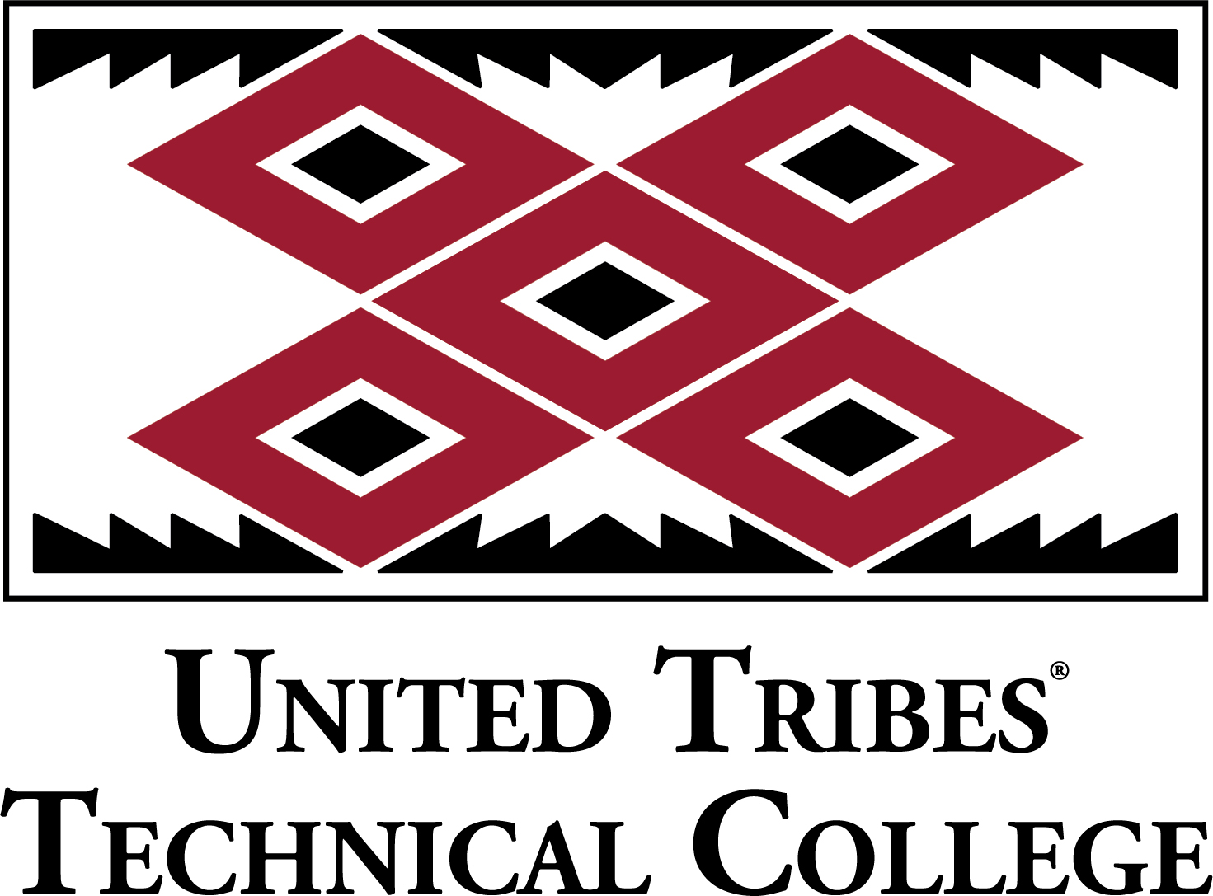

Strategic Plan Annual Report
2017 -2018 Academic Year
Submitted by: Leah Woodke, PhD
Institutional Research Director
The Office of Institutional Research

Executive Summary

UTTC has completed Year 3 of its Five-Year Strategic Plan
The United Tribes Technical College strategic plan was developed as a tool to ensure that “UTTC continues to operate at the highest level possible in the provision of programs of study that prepare the student for the ever changing workforce.”
The UTTC Strategic Plan is aligned to the institutional mission to provide a quality post-secondary education and supports the institution’s core values.

UTTC Mission
United Tribes Technical College provides quality post-secondary education and training to enhance knowledge, diversity, and leadership for all indigenous nations.

UTTC Core Values
Diversity
Education
Leadership
Integrity
Valor
Empowerment
Respect

The UTTC Strategic Plan addresses six strategic areas
1 | Commitment to  Student Learning | Strategy 1a: Improve and sustain instruction through the assessment of student learning outcomes  Strategy 1b: Employ highly qualified faculty
2 | Student Success  and Completion | 2a: Improve quality and integration of services throughout the learner experience  2b: Increase degree completion rate  2c: Increase internship and job-shadowing opportunities and job placement rates  2d: Deliver comprehensive alumni services
3 | Recruitment and  Retention of Students  and Employees | 3a: Develop and implement student recruitment and retention plans  3b: Offer student academic and athletic scholarships  3c: Develop and implement a marketing plan  3d: Develop a competitive salary schedule for the college – collective bargaining  3e: Staff professional development
4 | Institutional Research,  Culture & Effectiveness | 4a: Be proactive in maintaining accreditation and exploring trending opportunities  4b: Develop and implement a concise, sustainable institutional assessment system for continuous improvement  4c: Develop an institutional research agenda  4d: Institutionalize and sustain American Indian culture
5 | Infrastructure Improvement,  Renovation and  New Construction | 5a: New construction  5b: Renovation of existing structures  5c: Improve and update technology
6 | Expanded Funding for  Self-Sustainability | 6a: Search for additional funding sources (federal, state, private, etc.) to provide for self-sustainable campus  6b: Increase external and internal funding opportunities

Strategic Area #1: Commitment to Student Learning
Assessments of student learning outcomes in written
communication demonstrate student growth at UTTC.
UTTC hires highly qualified faculty to teach in their respective fields.
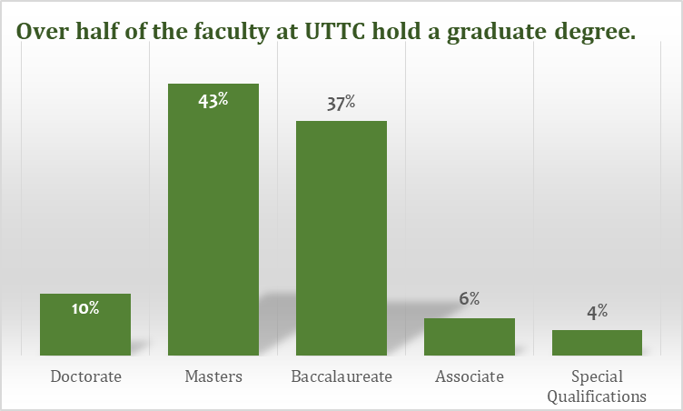
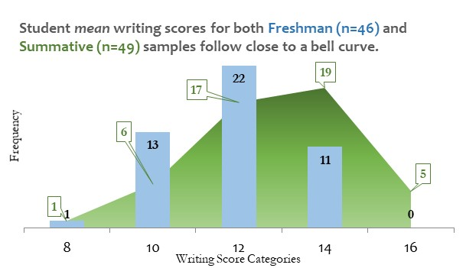

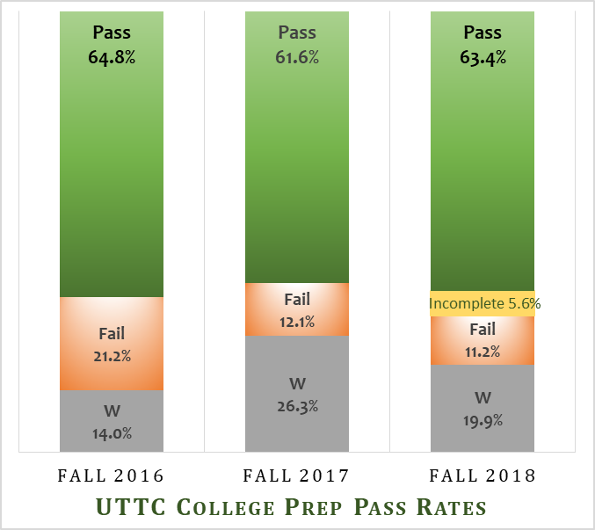
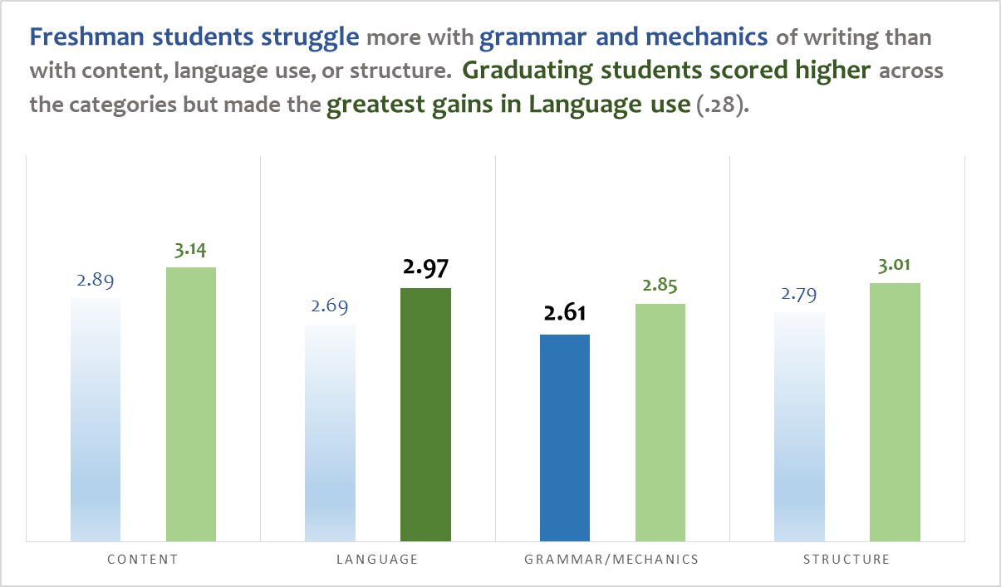
College Prep courses outcomes continue to improve.

Strategic Area #2: Student Success and Completion
UTTC implemented a Native American Tuition Waiver, Emergency Aid, and an Internship program, which helped students stay in college.

There were 33 students who received Emergency Aid last year; 88% stayed in school. UTTC also provides a “Band Aid Room” that offers students baby food, cleaning supplies and other general items when needed.*

*Data from National Student Clearinghouse

There were 6 students who participated in internships last year earning $11 per hour; 100% graduated or returned the next semester to continue their studies.

*Data from National Student Clearinghouse.

Students who receive the
Native American Tuition Waiver continue to have significantly better outcomes than students prior to the waiver program.

*Data from UTTC Jenzabar Data System.

Strategic Area #3: Recruitment and Retention of Students and Employees

Strategic Area #4: Institutional Research, Culture & Effectiveness
UTTC is working with state and national entities to improve its institutional research capabilities.

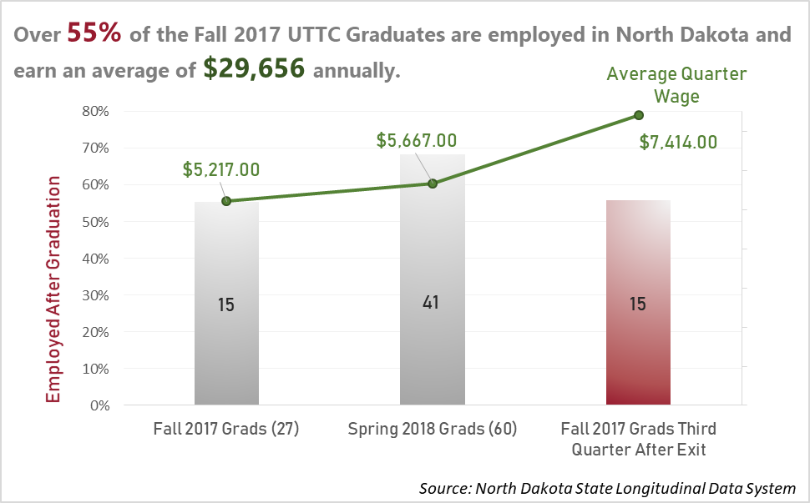

The State Longitudinal Data System helps UTTC see employment rates and wage data of its graduates.

According to the SENSE Survey administered in fall of 2017, many of our students experience food security issues.

External Data Sources:
- The National Student Clearinghouse (NSC)
- The Center for Community College Student Engagement
- North Dakota State Longitudinal Data System (SLDS)
- National Center for Educational Statistics

Strategic Area #5: Infrastructure Improvement, Renovation and New Construction

Strategic Area #6: Expanded Funding for Self-Sustainability

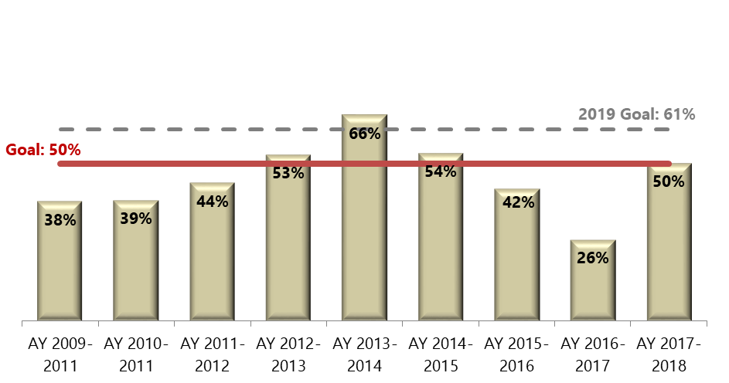
Completion rates for students in Career and Technical Education Program funded by Carl Perkins are impacted by a variety of factors. UTTC met its goal for CTE student completion.
Figure 1A new goal of 61% has been set for next academic year

UTTC President Leander “Russ” McDonald, PhD (Dakota/Sahnish/Hidatsa), President’s Message; UTTC Strategic Plan 2015-2020

