

**Book Purchasing Instructions**

**UTTC Bookstore Samantha Horse Looking is a great resource for any questions you have with our online book buying process offered through BNC Services.**

Samantha can be reached at shorselooking@uttc.edu or 701-221-1459.

If you need help, please contact her and she can assist you step by step.

The bookstore hours are Monday-Friday 8am to 5pm and additional information can be found here <https://uttc.edu/bookstore>

**Here is a Step-by-Step Guide or UTTC Students Purchasing Books**

1. **Check your student email (**[**yourname@uttc.stu**](mailto:yourname@uttc.stu)**) to obtain your “Voucher ID”**
2. **Once received, go to the BNC website by using your browser (**[**https://bncvirtual.com/uttcbookstore**](https://bncvirtual.com/uttcbookstore)**) or by clicking on the button to purchase books on the Bookstore webpage “ORDER YOUR TEXTBOOKS”**

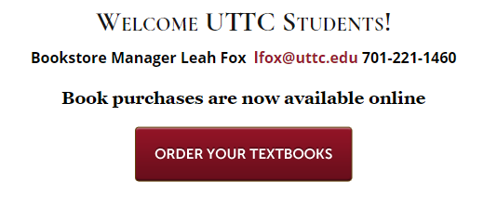

1. **If using a Voucher ID for purchase, click the “Use It Here” button in the middle of the page**

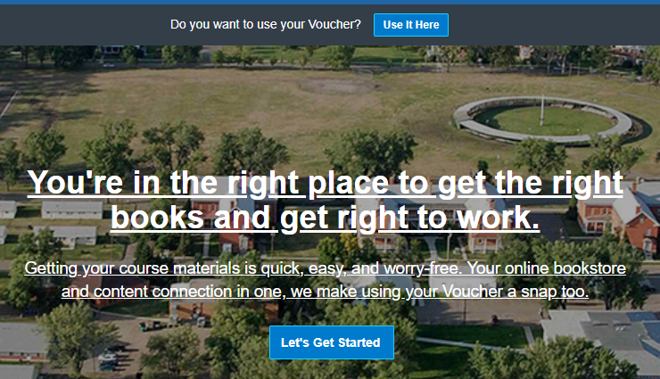

1. **Fill in the Student ID & Voucher ID boxes, then click “Access Your Funds” button**

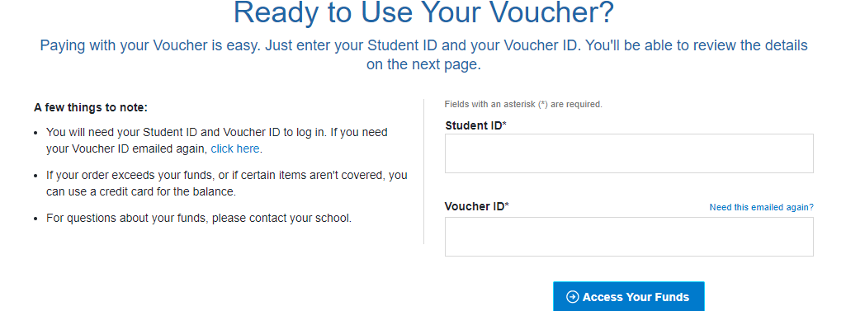

1. **UTTC Students are able to shop by schedule.** 
   * What this means is that once you input you’re Student ID & Voucher ID, your list of courses and textbook options should automatically pop up (including your guaranteed buyback price).
   * If it doesn’t automatically pop up, manually enter your courses in the “Your Course ID” in the “Getting Started” page.
2. **Once entered, the page will show which materials are required for your courses.**
3. **Choose which book options you would prefer, and add them to you cart.**
4. **Once you have finished and have created your account, you have two options of where you would like your books to be sent.** 
   * If you would like to pick them up at the Campus Bookstore, use the college address: 3315 University Dr. ATTN BKST, Bismarck ND 58504.
     + If choosing this option, make sure to enter a valid phone number so we can contact you when your package arrives.
   * If you prefer to have them delivered to your door, provide your **physical address.** The delivery will be made by UPS.
     + Note- books will not be delivered to PO Boxes