 ***United Tribes News*** [**www.uttc.edu**](http://www.uttc.edu)

FOR RELEASE August 6, 2025

**Dedication program set for WWII internment memorial at UTTC**

***BISMARCK FORT IMPRISONED JAPANESE AMERICANS DURING WORLD WAR TWO***



Winter 1942 image of confinement barracks buildings, a guard tower and fence line at Bismarck’s Fort Lincoln, which became known as the “Snow Country Prison.” (UTTC Library-Archive)

**U**nited Tribes Technical College (UTTC) will host a dedication Friday, September 5 for the “SNOW COUNTRY PRISON Japanese American Internment Memorial.” A public program begins on the college campus at 1 p.m. in the courtyard of the college’s main Education Building on All Nations Drive. The tribal college campus was once a military post.

Bismarck’s Fort Lincoln earned the name “Snow Country Prison” when converted for human confinement during World War II. There, the U.S. Justice Department imprisoned civilian German nationals and Japanese Americans; many of the latter were U. S. Citizens.

“This memorial honors the history and resilience of Japanese Americans who were unjustly incarcerated during World War II,” said UTTC President Leander R. McDonald (Spirit Lake Dakota/Arikara). “As Native People, educators and stewards of this site, we understand the parallel history here and consider it our sacred trust to memorialize this part of the internment.”

**PROGRAM**

The “Snow Country Prison” dedication takes place on opening day of the annual United Tribes Technical College International Powwow.

The dedication program will blend Native and Japanese ceremonial customs. Included will be a Native drum group and Japanese drummers and dance performers. Native American and Buddhist blessings will be provided. Presentations will explain Bismarck’s connection to the Japanese American internment, describe the memorial design, and recognize supporters and donors.

To conclude the program, participants and spectators will be invited to place Tsuru (paper cranes) or Native Prayer Ties in a crease in the memorial wall designed for the purpose.

**CULTURAL BOND**

Planning for the memorial began 15-years-ago when the college started gathering input from internee survivors and family members. More recently since 2019, a committee of Japanese Americans familiar with the internment, joined with UTTC to plan and fund the project.

The design emphasizes the intersectional bond between cultures at this site. It features a center drum circle, like a Native Medicine Wheel, flanked by two interpretive walls. One bears the names of those interned at Fort Lincoln; the other is a combined timeline of regional Native history and the Japanese American internment. Design work and construction was guided by a team from the international non-profit organization MASS ([Model of Architecture Serving Society](https://massdesigngroup.org/)).

**PRIVATE AND PUBLIC FUNDING**

The “Snow Country Prison” memorial is seen as an educational and commemorative collaboration, rooted in two, often marginalized chapters of American history. Funding comes from both public and private sources. The National Park Service approved grants for planning and the start of construction through the agency’s [Japanese American Confinement Sites program](https://www.nps.gov/orgs/1379/index.htm). UTTC provided significant matching and in-kind contributions. An online campaign allowed many individual citizens to show their support. Project completion was assured by a generous award from the [Henri and Tomoye Takahashi Charitable Foundation](https://www.takahashifoundation.org/), San Francisco, CA.

**SPECIAL GUESTS**

The dedication is expected to draw Japanese American visitors to Bismarck for a pilgrimage to the former confinement site.

Satsuki Ina, cofounder of [Tsuru for Solidarity](https://tsuruforsolidarity.org/), and member of the Snow Country Prison Advisory Committee, will give a talk about the memorial’s significance. Her father, Itaru Ina, coined the phrase “Snow Country Prison” in a haiku poem he wrote when incarcerated at Fort Lincoln in 1945-46.

Ina is the author of a new book about the internment “[The Poet and the Silk Girl: A memoir of Love, Imprisonment, and Protest](https://www.amazon.com/Poet-Silk-Girl-Imprisonment-Protest/dp/1597146269).” A book signing is scheduled following the dedication program.

On display in the UTTC Library Sept. 5 and 6 will be the Ireicho ([Sacred Book of Names](https://ireizo.org/tour/)) containing the names of 125,284 people of Japanese ancestry incarcerated in the U.S. during World War II. The large volume was compiled by the Reverend Duncan Williams of Los Angeles, CA, a member of Snow Country Prison Advisory Committee. He will offer a Buddhist blessing during the dedication and guide the stamping of names in the Ireicho for Japanese Americans. Appointments can be scheduled online [here](https://ireizo.org/tour/).

The dedication includes music and dance performances. [TaikoArts Midwest](https://www.taikoartsmidwest.org/ensodaiko), Minneapolis/St. Paul, MN, presents an energetic music and dance performance to the beat of the taiko drum.

The [Aisawa Dance Theater](https://www.facebook.com/AiDanceTheater/), of New York, NY, will present the interpretive dance performance “Say Something,” choreographed and performed by Janet Aisawa and Osamu Uehara, with a sound score by Osamu Uehara.

Also included in the day’s events is a viewing of "Defiant to the Last," a new documentary video about government efforts to denationalize and deport Japanese American U. S. Citizens who were outspoken while in confinement about their constitutional rights.

**EVERYONE WELCOME**

These events are open to the public. Everyone is welcome at United Tribes Technical College, 3315 University Drive, Bismarck, ND, 58504, 701-255-3285, [www.uttc.edu](http://www.uttc.edu).

**BOOKS AVAILABLE**

Fort Lincoln internment related books are available on site through the United Tribes Bookstore, Angela Heck, Manager, 701-221-1461 or 1459, [aheck@uttc.edu](mailto:aheck@uttc.edu).

**Book signings:**

**Friday, Sept. 5** (Following the dedication program in UTTC Education Bldg.)

* Satsuki Ina, [The Poet and the Silk Girl: A memoir of Love, Imprisonment, and Protest](https://www.amazon.com/Poet-Silk-Girl-Imprisonment-Protest/dp/1597146269)

**Saturday, Sept. 6**

* Elaine Koyama, [*Between Two Freedoms*](http://www.elainekoyama.com) a fictionalized story about love and the incarceration of Japanese in America during World War 2 (powwow arena venders’area)

**COLLEGE GOVERNING TRIBES**

United Tribes Technical College is governed by the five tribes located in whole or in part in the state of North Dakota: Sisseton-Wahpeton Oyate; Spirit Lake Tribe; Standing Rock Sioux Tribe; Three Affiliated Tribes of the Mandan, Hidatsa, Arikara Nation; and Turtle Mountain Band of Chippewa Indians.

More Information: Dennis J. Neumann, UTTC Library/Archive, [opi@uttc.edu](mailto:opi@uttc.edu), 701-221-1386

-0-

DEDICATION PROGRAM

**SNOW COUNTRY PRISON Japanese American Internment Memorial**

**FRIDAY, SEPTEMBER 5, at 1 p.m.**

UTTC Education Building Courtyard

Everyone Invited! Everyone Welcome!

United Tribes Technical College

3315 University Drive

Bismarck, ND 58504

[www.uttc.edu](http://www.uttc.edu)

701-255-3285

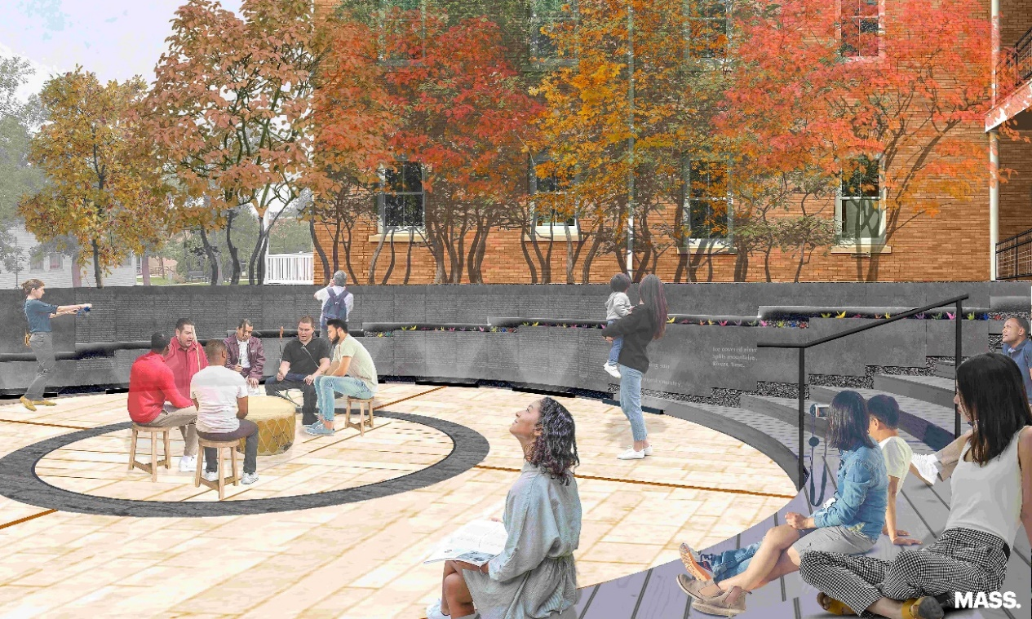

Design rendering of the “Snow Country Prison” memorial, showing the drum circle and names wall. (MASS, Model of Architecture Serving Society)

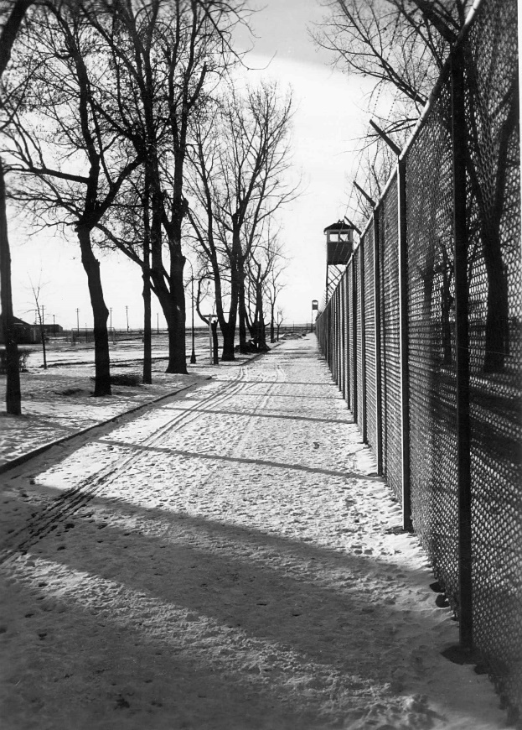

Guarded fence line of Fort Lincoln Internment Camp, where 1,920 Japanese Americans were imprisoned. In total, 125,284 people of Japanese ancestry were incarcerated in camps across the U.S. during World War II.

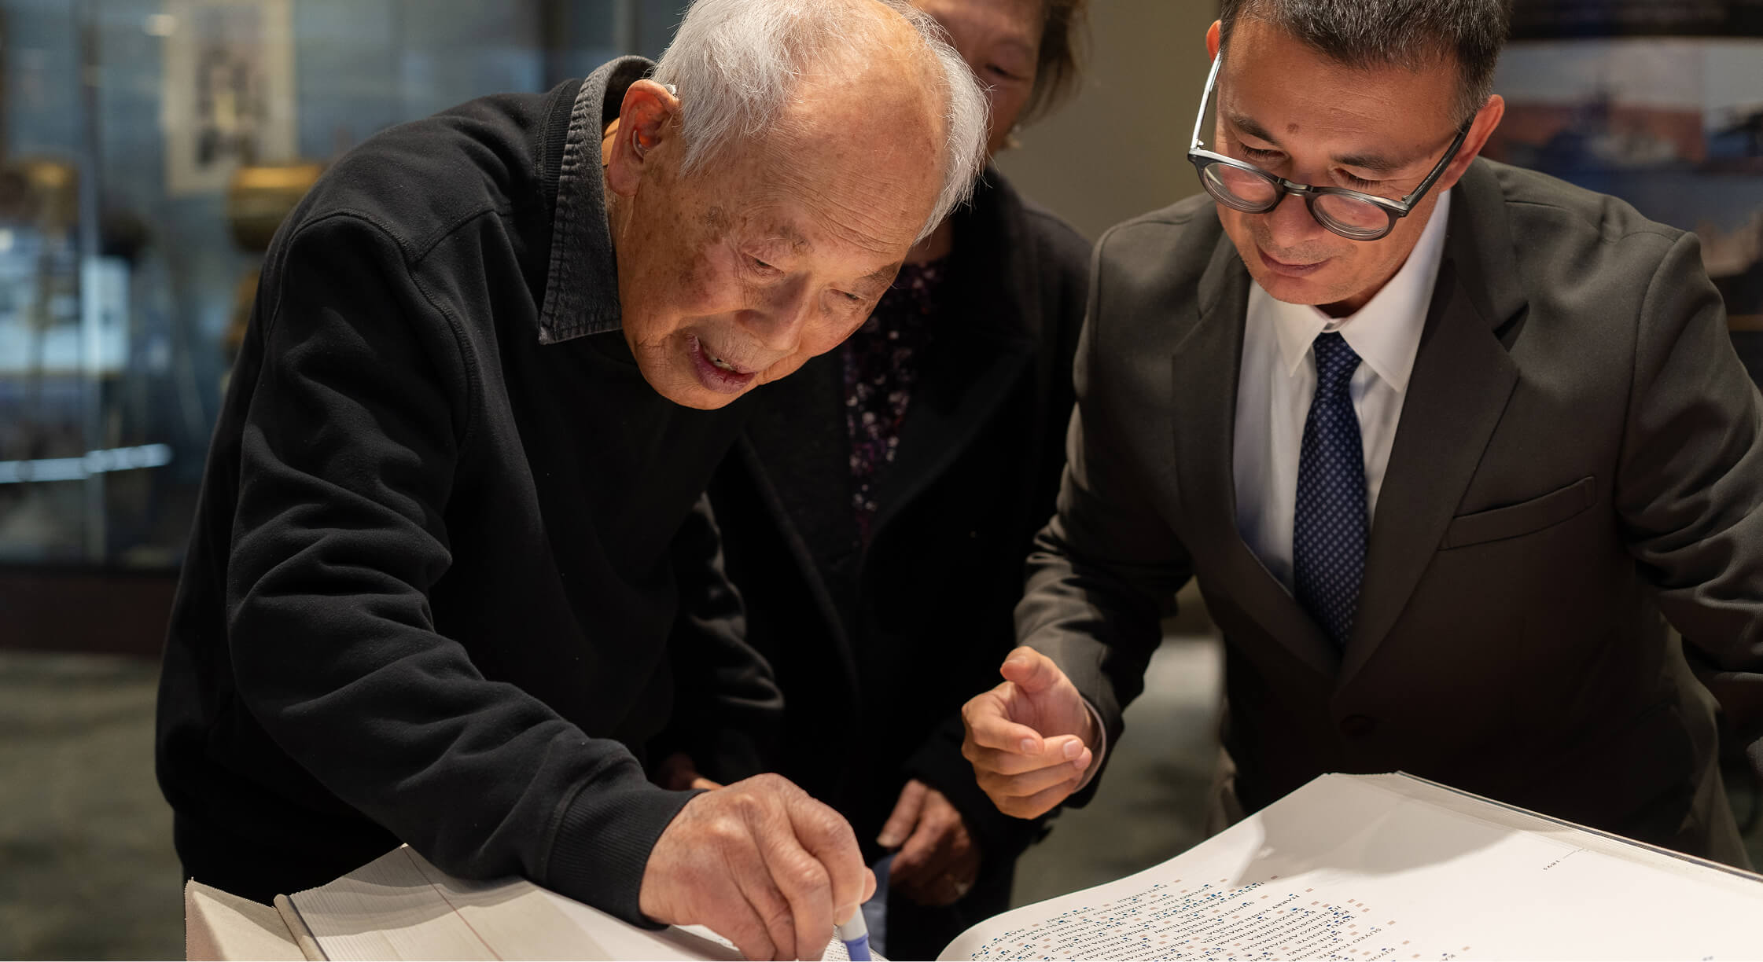

At right, Duncan Williams guides Masaharu Ishii in placing a stamp by his name in the Ireicho (Sacred Book of Names). The book will be on display and available for stamping Sept. 5 and 6 in the United Tribes Technical College Library.

<><><><><>